Linux Programming

*Submitted in partial fulfillment of the requirements for the degree of BCA*

***Submitted By***

**Name -Sandeep**

**Roll No.- 41221147**

**Name of faculty**

**Mrs, Deepika**

Designation Department of BCA

**DSEU**



**Department of BCA Ambedkar Institute of Technology**

**Shakarpur Campus-1**

**DSEU**

**New Delhi, India 2022**

**Que 1 Write the Linux command to display calendar with various options.**

**Answer: -** command and syntax– $cal

Show current month calendar on the terminal

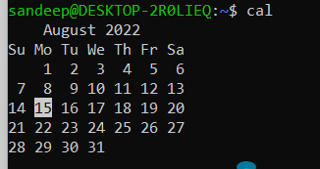

**Command and syntax- $ncal**

To display current month with weekdays vertically printed

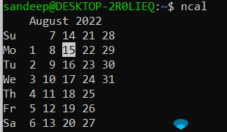 **Example**:

**Command and syntax** - $cal -3

Shows calendar of previous, current and next month

Example: -

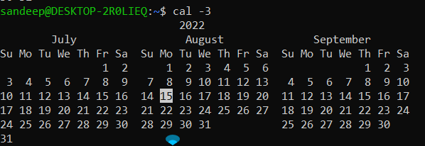

**Command and syntax- $cal y**

Shows the calendar of the complete current year with the current date highlighted.

Example:

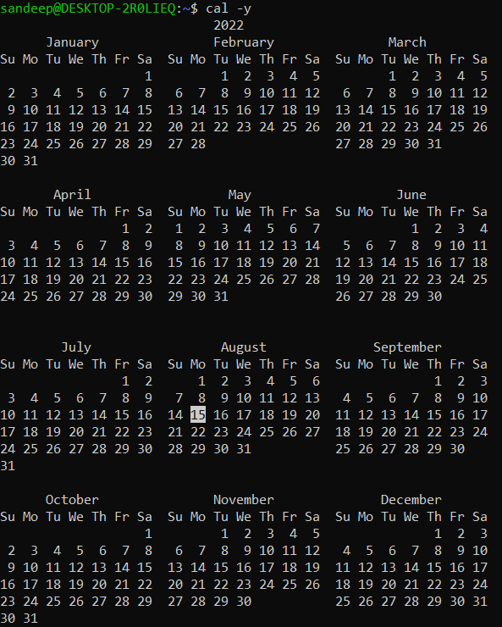

Command and syntax - $**cal -j**

Shows the calendar of the current month in the **Julian calendar**format not in the default **Gregorian calendar** format.

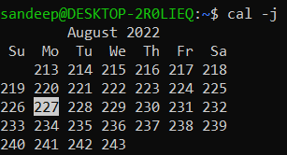

**Que 2 Write a linux command to display date with various options.**

Answer: - **Command: $date**: - the date command displays the current date and time, including the abbreviated day name, abbreviated month name, day of the month, the time separated by colons, the time zone name, and the year.

Example:

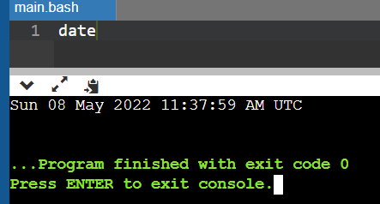

**Command: $date- u**

Displays the time in GMT(Greenwich Mean Time)/UTC(Coordinated Universal Time )time zone.

Example:

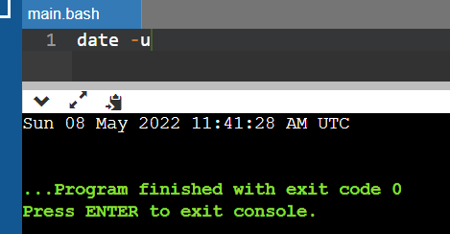

**Command: $date --date=”<format>”**

Displays the given date string in the format of date. But this will not affect the system’s actual date and time value. Rather it uses the date and time given in the form of string

Example:

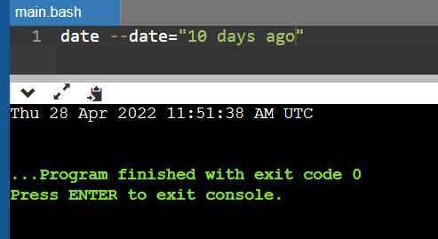

To format the date command’s output, you can use control characters preceded by a + sign. Format controls begin with the % symbol and are substituted by their current values.

These are the most common formatting characters for the date command:-

**%D – Display date as mm/dd/yy**

**%Y – Year (e.g., 2020)**

**%m – Month (01-12)**

**%B – Long month name (e.g., November)**

**%b – Short month name (e.g., Nov)**

**%d – Day of month (e.g., 01)**

**%j – Day of year (001-366)**

**%u – Day of week (1-7)**

**%A – Full weekday name (e.g., Friday)**

**%a – Short weekday name (e.g., Fri)**

**%H – Hour (00-23)**

**%I – Hour (01-12)**

**%M – Minute (00-59)**

**%S – Second (00-60)**

**Que 3 Write a linux command to display the list of users who are currently using** **linux server.**

Answer: - **finger:** This command is a user information lookup command which gives details of all the users logged in. It provides details like login name, user name, idle time, login time, and in some cases their email address even.

**Syntax: - $finger**

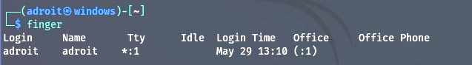

**Command: - $finger -q**

To get information about user brown at a local host in short form, enter:

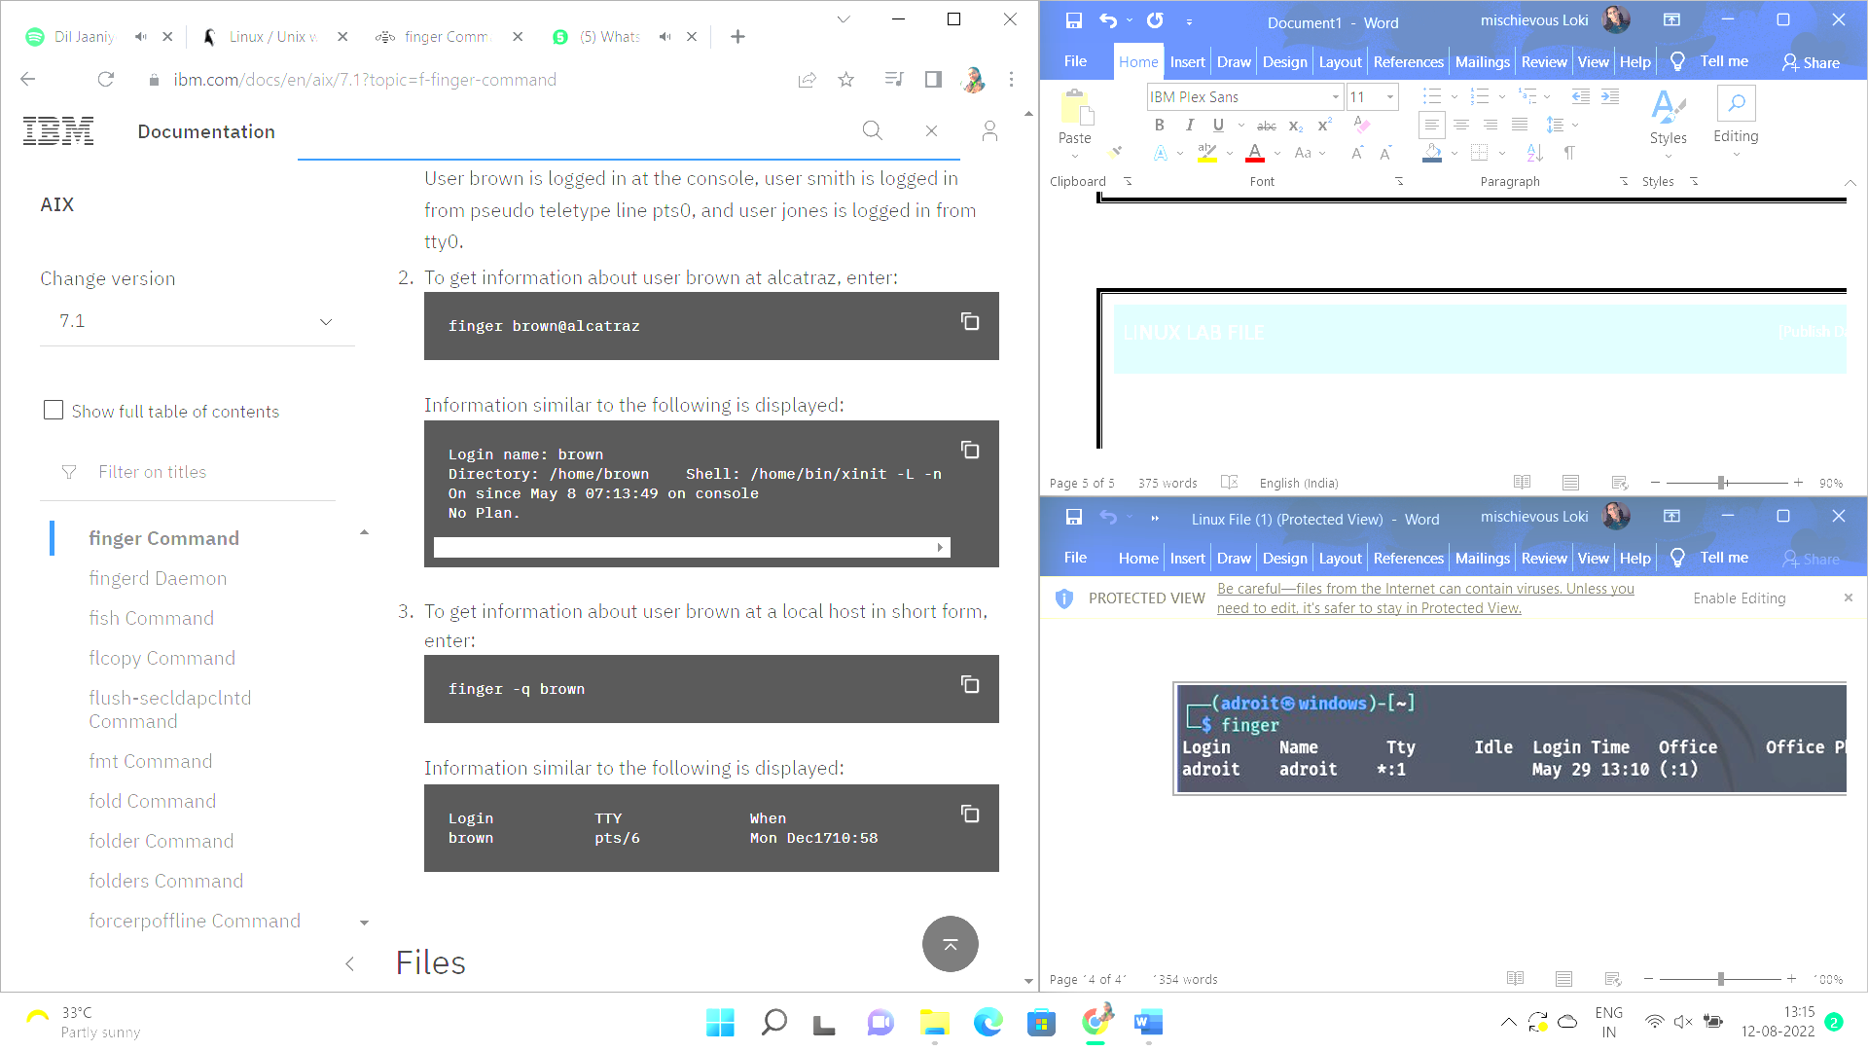

**Command: - $finger -s sandeep**

To get idle status and login details of a user.



**Command: - $finger -p sandeep**

To avoid printing PGP key, plan and project details

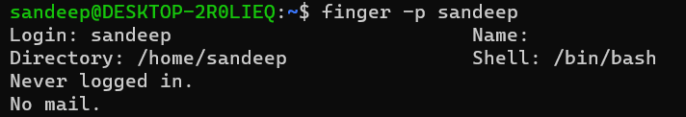

**Command: - $finger sandeep**

To finger or get details of a single user.

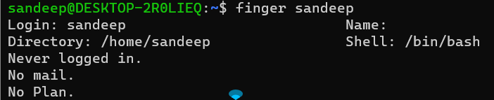

**Que 4 Write a linux command to display your system details.**Answer: - To know only the system name, you can use the **uname** command without any switch that will print system information.

**Syntax: - $uname**

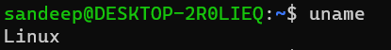

**Command: - $uname -n**

To view your network hostname

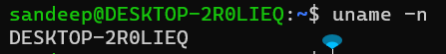

**Command: - $uname -v**

To get information about kernel-version,

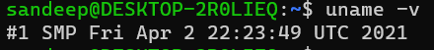  
**command: - $uname -a**

All this information can be printed at once by running the **‘uname -a’** command as.



**Command: - $uname -r**

To get the information about your kernel release

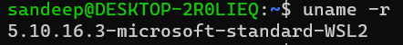

**Que 5 Write a linux command to display your user name.**answer: - **command- $who** :- It will display the host name & user name.

To print current user name, we use command “whoami” where at the position of “amI” system automatically assumes “-m” option.

**Command: - $whoami**

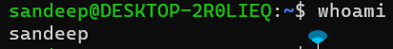

**Que 6 :- Write linux command to list all the directories and files on the server.**answer:- The ls command is used to list files or directories in Linux and other Unix-based operating systems.

**Syntax:- $ls**

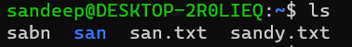

**Command:- $ls** [directory path here]

to list the contents of another directory:

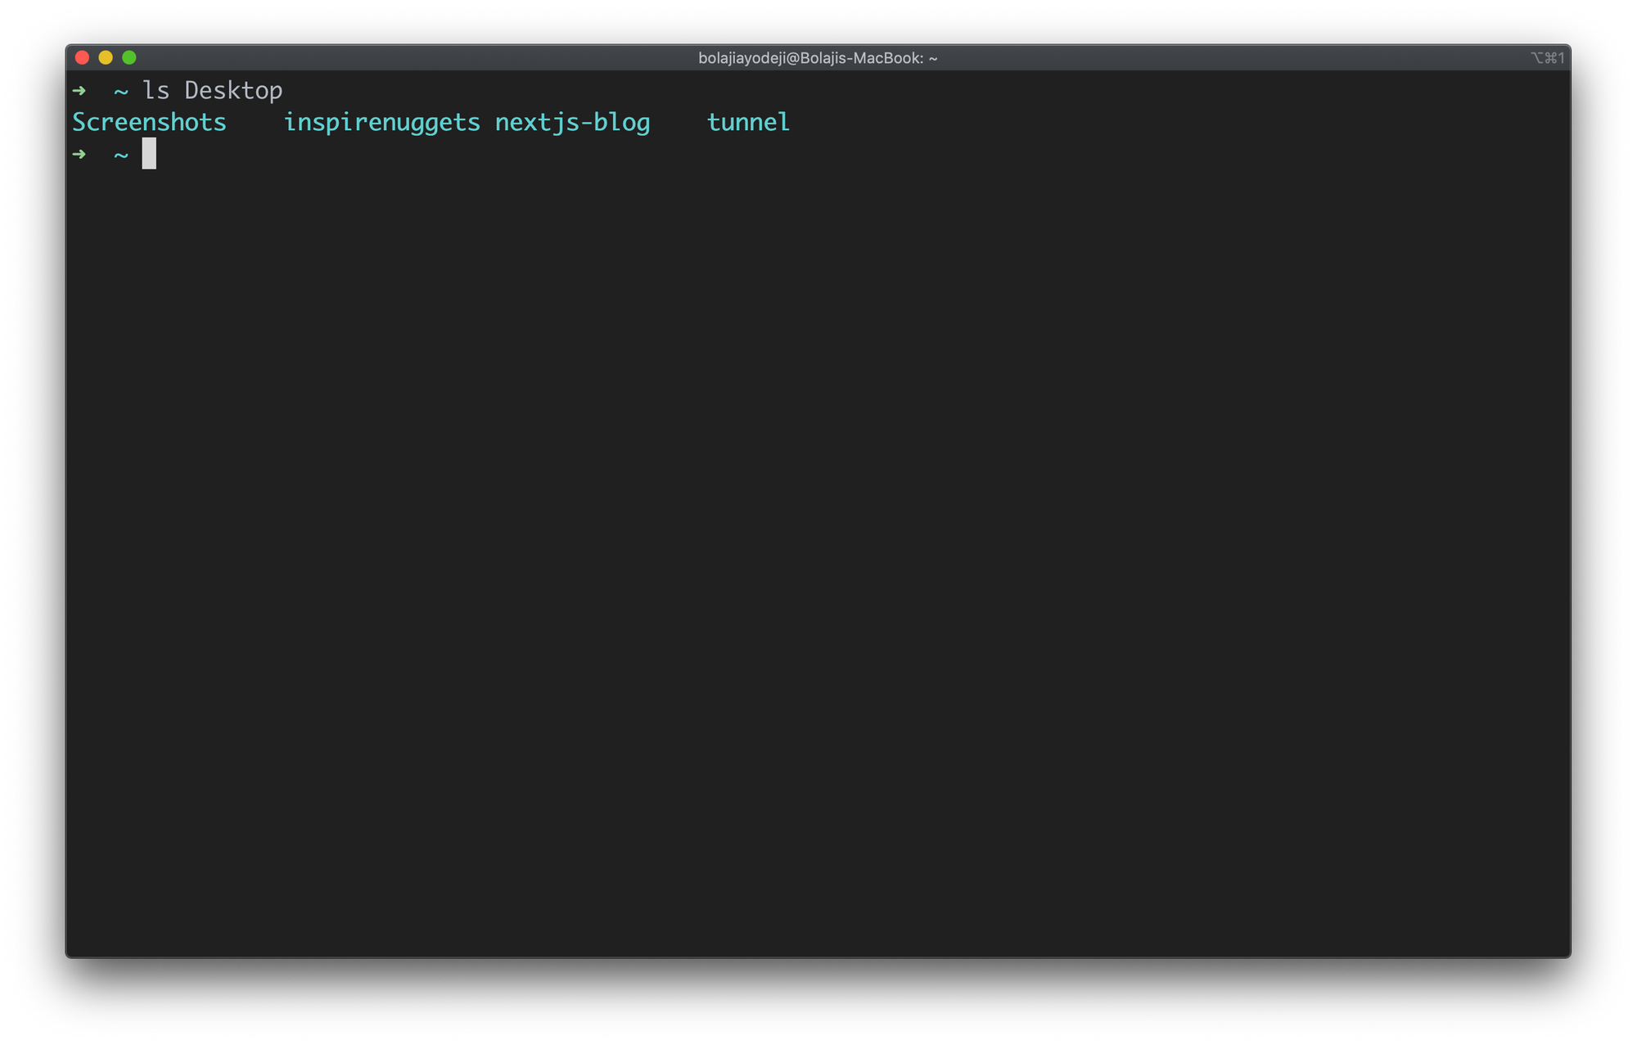

**Command:- $ls /**

to list the contents of the root directory:



**Command:- $ls ~**

to list the contents in the users's home directory:

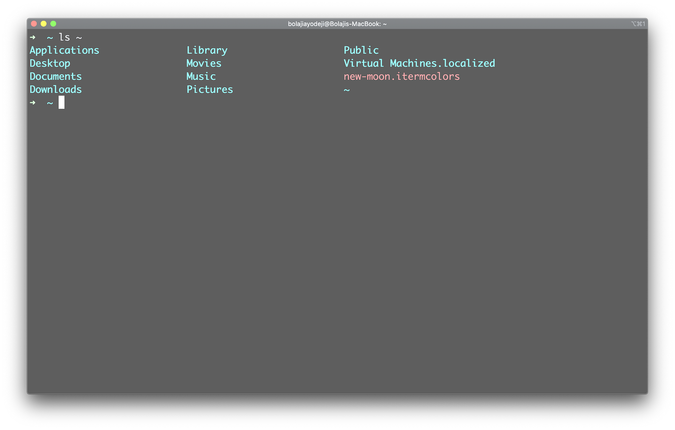

**Command:- $ls -s**

To list files and subdirectories with their size.

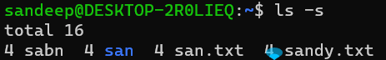

**Que 7 -Write the linux command to display the content of a file**answer: - **$Cat** -simply prints the content of the file to standard display i.e. your screen.

**Syntax: - $cat filename**

**Example: -$cat foss.txt**

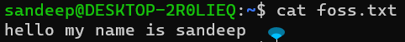

**syntax: - $cat file1 file2**

**To view multiple files** **Command:**

Example: - **$cat test test1**



**Command: - $cat -n filename**

To see the line numbers of a file.

Example: -

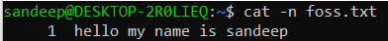

**Command: - $cat -e filename**

shows at the end of the line and also in space showing ‘**$**‘ if there is any gap between paragraphs. This option is useful to squeeze multiple lines into a single line.

Example: -



**Command: -$cat -T filename**

we could see **TAB** space is filled up with the ‘**^I** ‘characters.

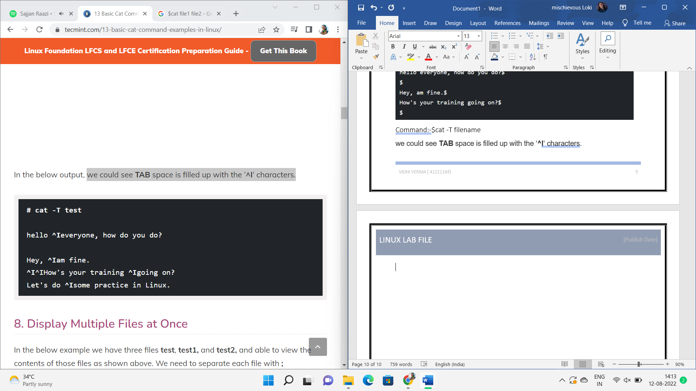

**Que 8 Write the linux command to print the content on standard output device.**Answer: - The **‘>** ‘symbol is used for output (STDOUT) redirection.

**Syntax: - ls -al > listings**

 ls -al is re-directed to file “listings” instead of your screen.

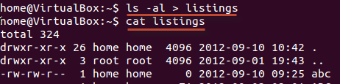

If you do not want a file to be overwritten but want to add more content to an existing file, then you should use **‘>>** ‘operator.

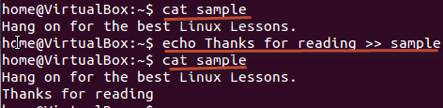

**Que 9 Write the linux command to perform calculations.**answer: - **bc command** and **expr command** for doing arithmetic calculations.

**Syntax: - $bc [option] [file]**

the command **bc** on command prompt and simply start calculating your expressions.



**Command:- $bc -l**

to sets the default scale (digits after the decimal point) to **20**

**example: -**

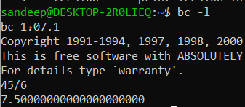

**command:- $bc -c**

To convert an infix expression to Reverse Polish Notation (RPN)

Example:-

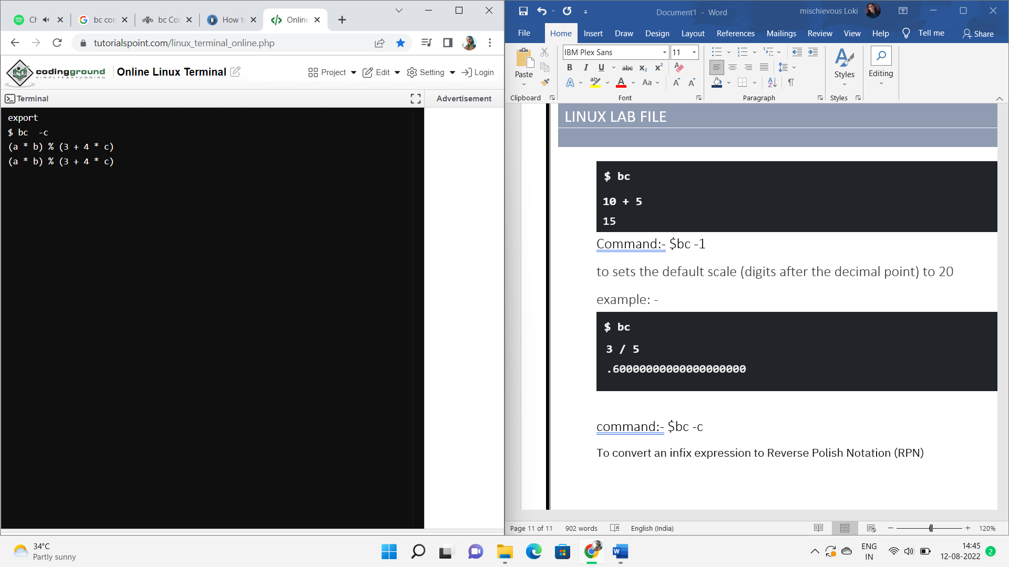

**Que 10 Write the linux command to show the current working directory.**Answer:- **pwd** (print working directory) – The pwd command is used to display the name of the current working directory in the Linux system using the terminal.

**Syntax:- $pwd**

Example:-

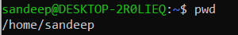

**Command: - $ pwd -L**: Prints the symbolic path.



**Command: - $pwd -P**: Prints the actual path.

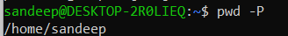

**Command:- pwd –help**

Use the --help option to see the pwd command help file and the available options:

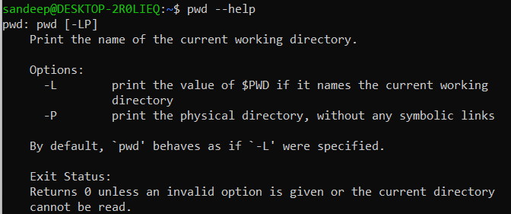

**Que 11 Write the linux command to get help with various options.**answer: - **–help displays** usage information and a list of options you can use with the command.

Example: - **$wget –help**

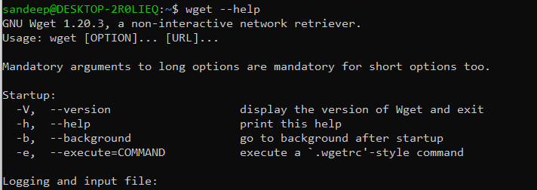

**Command: - $help -d cd**

### -d option to output short description for each topic



**Command: - $help -s pwd**

-s flag displays the command syntax of the specified command.

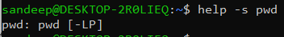

**Command: - $help -m pwd**

The -m flag gives the output in manpage like format.

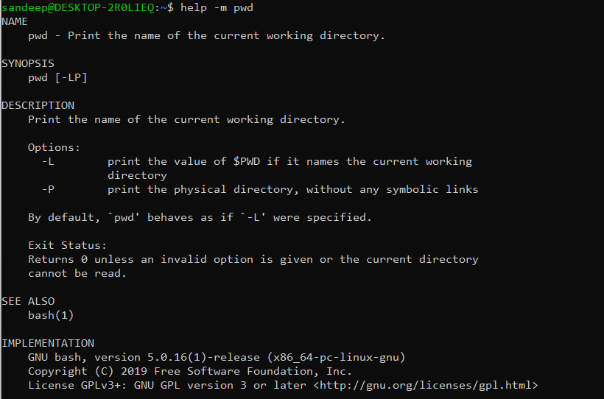

**Que 12 Write the linux command to display what all users are currently doing  
answer:- $w** -is used to display what all users doing currently

Example:- 

**Command: - $w -h**

display the output without the header containing system details and field labels.

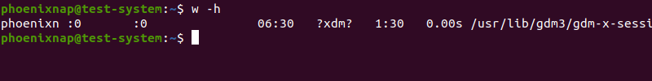

**Command: - $ w -s**

 To display the short format,

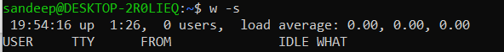

**Command: - $ w -i**

to displaying their IP address



**Que 13 Write the linux command to create a directory.**answer:- the mkdir stands for 'make directory'. With the help of mkdir command, you can create a new directory wherever you want in your system.

**Syntax:**

**mkdir <dirname>**

example:-

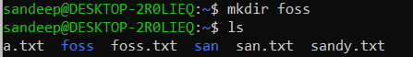

**command: - $ mkdir -v [directories]**

It displays a message for every directory creat 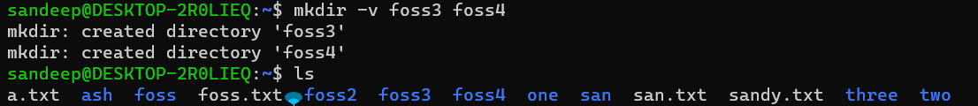

**Command:- $ mkdir -p [directories]**

the command to create parent directories as necessary. If the directories exist, no error is specified. 

**Command:- $mkdir -m a=rwx [directories]**

This option is used to set the file modes, i.e. permissions, etc. for the created directories.



**Que 14 Write the linux command to change the directory**answer:- The cd (“change directory”) command is used to change the current working directory in Linux and other Unix-like operating systems.

**Syntax:- $cd [OPTIONS] directory**

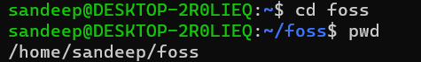

**Command:- $ cd /**

this command is used to change directory to the root directory, The root directory is the first directory in your filesystem hierarchy.

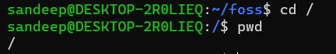

**Command: - $ cd ~**

 this command is used to change directory to the home directory.



**Command: - $ cd ..**

this command is used to move to the parent directory of current directory, or the directory one level up from the current directory. “..” represents parent directory.



**Command:- $ cd "dir name"** - This command is used to navigate to a directory with white spaces. Instead of using double quotes we can use single quotes then also this command will work.

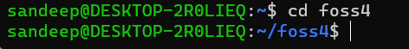

**Que 15 Write the linux command to remove a directory.**answer: - The rmdir command removes empty directories.

**Syntax: -$ rmdir** [**options] [directory name]**

Example: -

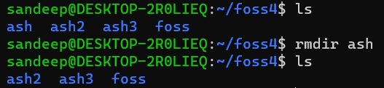

**Command: - $ rmdir -v**

lists each step of the process as the output:

Example: -



**Command: - $rmdir -p -v Example/Test**

This removes both the subdirectory and its hierarchical parent:

Example:-

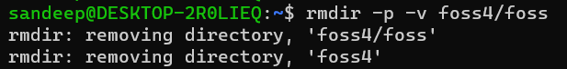

**Que 16 Write the linux command to delete a file.**

Answer: - The **rm** command in Linux OS is used to remove files from the command line.

Syntax: - **$rm [option] [file name]**

example: -

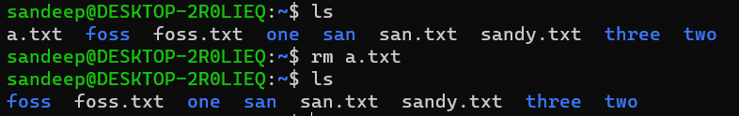

Command: - **$ rm -i**

the -**i** option makes the command ask the user for confirmation before removing each file.

Example:- 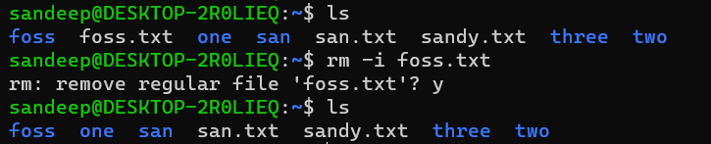

Command: - **$rm -f**

The **-f** option overrides this minor protection and removes the file forcefully.

Example: -

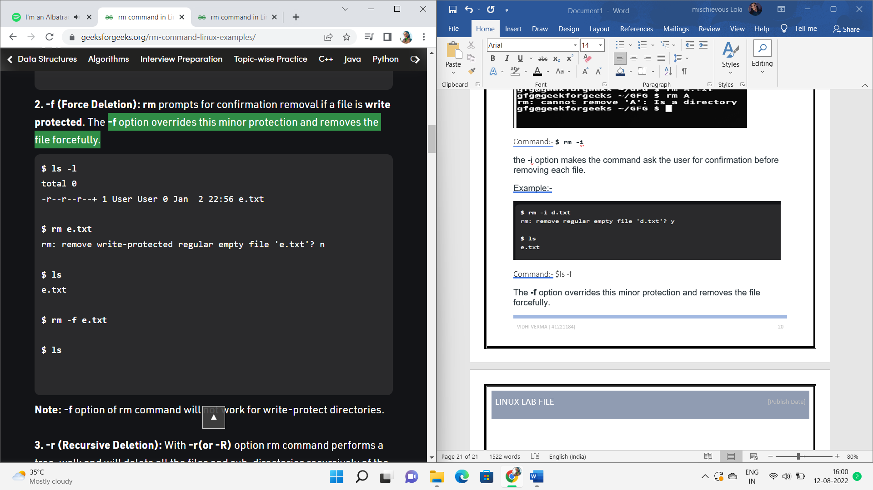

Command: - **$ rm -r**

performs a tree-walk and will delete all the files and sub-directories recursively of the parent directory. At each stage it deletes everything it finds.

Example: -

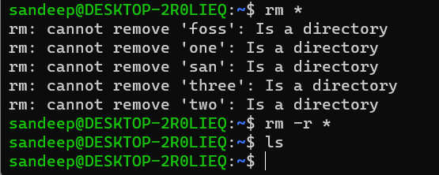

**Ques 17 Write the linux Command to copy a file to some other location**answer: - '**cp**' command is used to copy a file or a directory.

Syntax: - **cp <existing file name> <new file name>**

Example: -



**Command: - $ cp -i**

For interactive copying.

Example: -

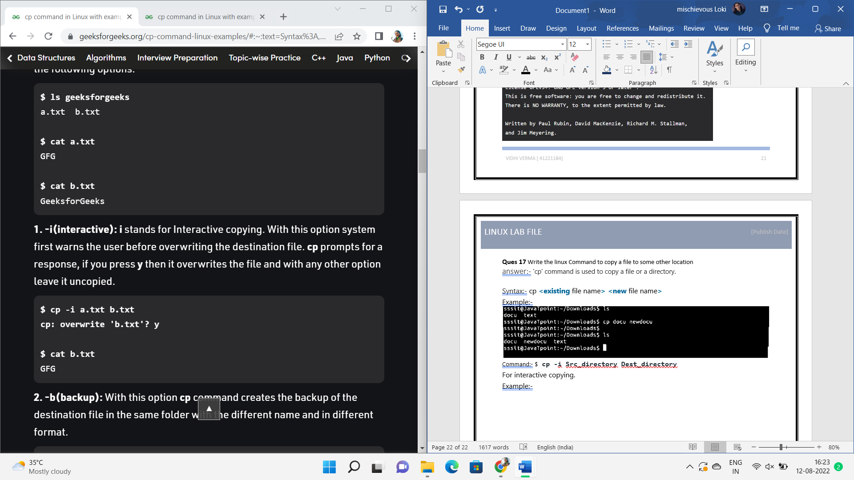

**Command: - $cp -b :-** With this option **cp** command creates the backup of the destination file in the same folder with the different name and in different format.

Example:-

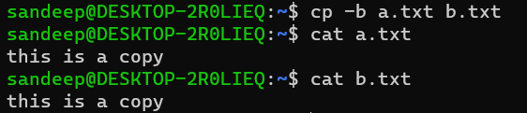

**Command:- $cp -f**

If the system is unable to open destination file for writing operation because the user doesn’t have writing permission for this file then by using **-f** option with **cp** command, destination file is deleted first and then copying of content is done from source to destination file.

Example: -

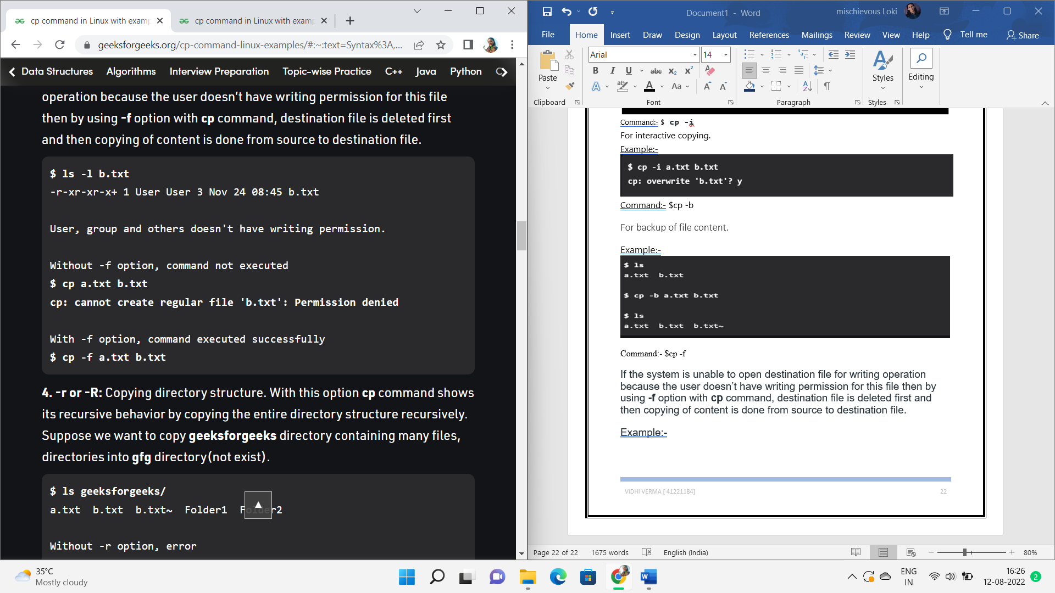

**Command: - $cp -p**

 the time of the last data modification and the time of the last access

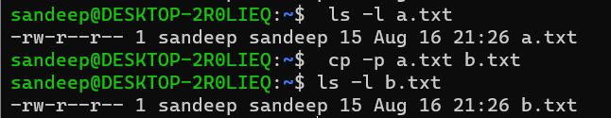

**Que 18 Write the linux command to move a file to some different location.**answer: - mv command is used to move a file from one location to another.

Syntax: - **$mv [source file name] [destination file name]**

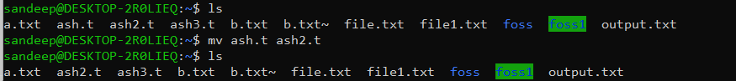

**Command: - $mv -i**

the -i option makes the command ask the user for confirmation before moving a file that would overwrite an existing file.

Example:-

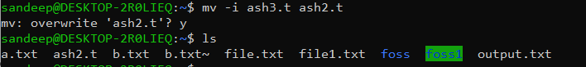

**Command: - $mv -n**

to never overwrite an existing file at the destination

Example:-



**Command: - $mv -u**

the file at the destination will be updated as the source file is more recent.

Example: -



**Command: - $mv -b**

It will create the backup file at the destination directory with the same name but with a **tilde (~)** appended to it.

Example: -

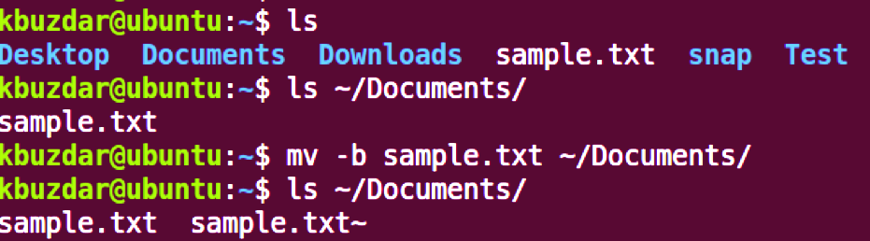

**Que 19 Write the linux command to compare the contents of two files**

Answer: - diff command is used to compare content of two files.

Syntax: - **$diff [option] [file1] [file2]**

Example: -

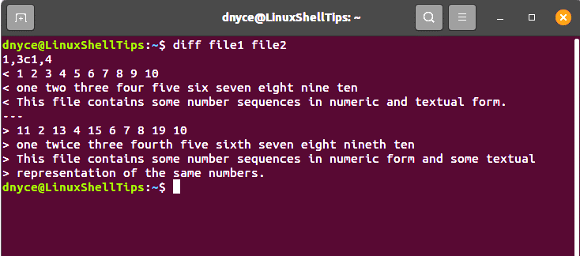

**Command: - $diff -s [file1] [file2]**

To tell that two files are identical or not.

Example: -

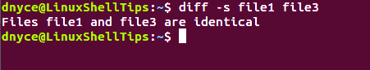

**Command: - $diff -s [file1] [file2]**

The use of the extra -s command argument makes this output possible. However, implementing it with two unidentical files will still output their differences.

Example: -

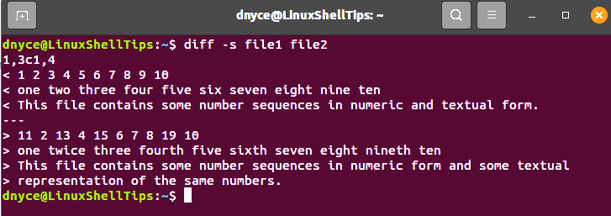

**Command: - $diff -q [file1] [file2]**

for a one-liner output on two files you suspect to be different.

Example: -

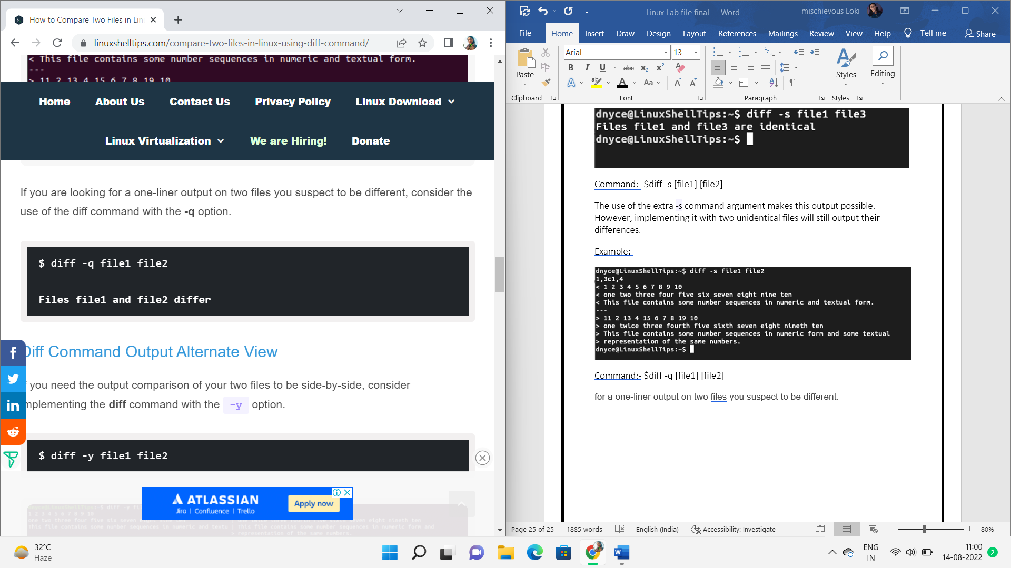

**Command: - $diff -y [file1] [file2]**

 the output comparison of your two files to be side-by-side.

Example: -

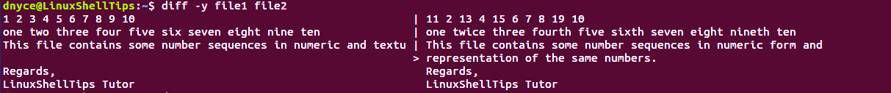

**Que 20 Write the Linux command to count the number of words, lines and sentences in the file**

**WC Command**

The wc command allows you to count the number of lines, words, characters, and bytes of each given file or standard input and print the result.

The syntax for the wc command is as follows: **wc OPTION... [FILE]...**

The options below allow you to select which counts are printed.

* -l, --lines - Print the number of lines.
* -w, --words - Print the number of words.
* -m, --chars - Print the number of characters.
* -c, --bytes - Print the number of bytes.
* -L, --max-line-length - Print the length of the longest line.

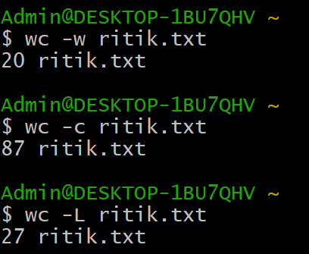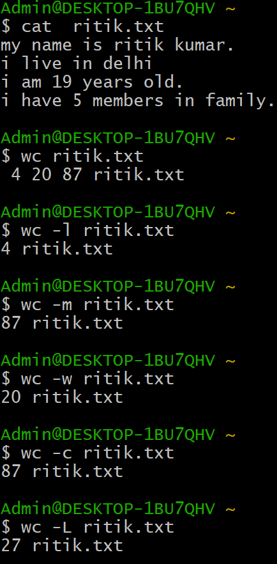

**Que 21 Write the linux command to see the data in octal format.**answer:- **od** command in Linux is used to convert the content of input in different formats with octal format as the default format.

**Syntax: od [OPTION]... [FILE]...**

example:-

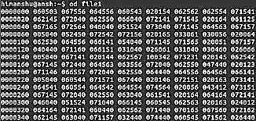

**Command: - $ od -b input.txt**

It displays the contents of input in octal format.

Example:-

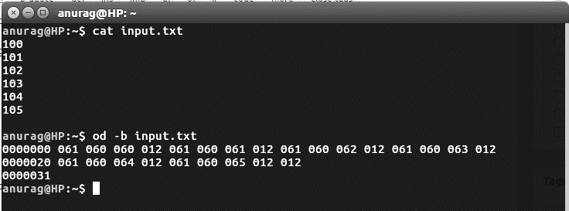

**Command: - $ od -c input.txt**

It displays the contents of input in character format.

Example:-

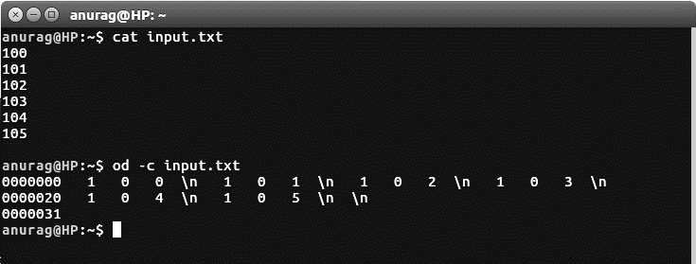

**Command: - $ od -An -c input.txt**

It displays the contents of input in character format but with no offset information.

Example:-

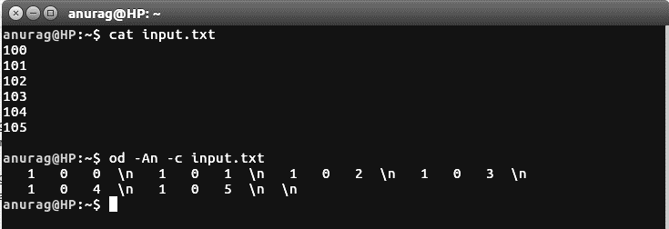

**Command: - $od -A input.txt**

It displays the contents of input in different format by concatenation some special character with -A.

Example:-

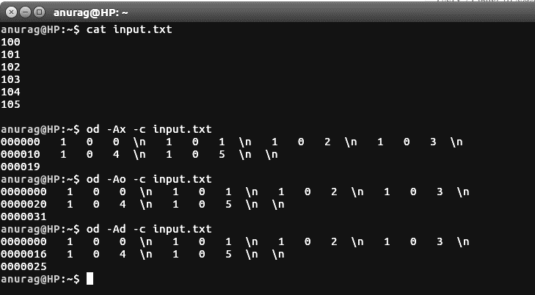

**Que 22 Write the linux command to give the alias name.**answer: - **alias**command instructs the shell to replace one string with another string while executing the commands. Removing an existing alias is known as unaliasing.

**Syntax:  alias [option] [name[=value] ... ]**

example:-

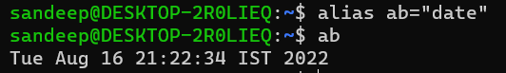

**Options for Alias command:**

**Command: - $ alias -p**

 prints all the defined aliases is reusable format.

Example:-

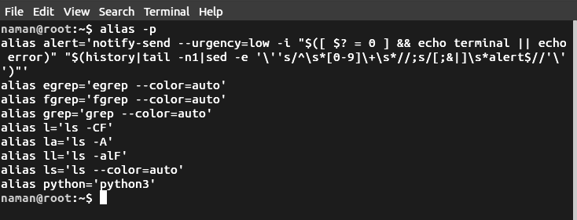

**Que 23 Write the linux command to view the exiting aliases.**

Answer:- Command:- $ alias -p

 prints all the defined aliases is reusable format.

Example:-



**Que 24 Write the linux command to unalias the exiting alias name.**answer:- We use unalias command for this purpose.

**Syntax: - $unalias [name]**

Example: -

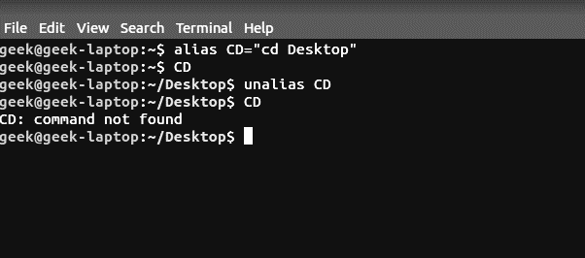

**Que 25 Write the linux command to display the hostname of the system.**answer:- The Linux hostname command is used to view or change a system’s domain and hostname.

**Syntax: - hostname [options]**

Example:-



Options of hostname command: -

**Command: - $hostname -s**

 to display the short version of the hostname, which is cut off at the first dot:

example:-

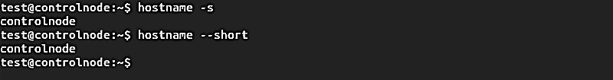

**Command: - $hostname -a**

 to display the alias (substitute hostname) of the host if one is set.

Example:-

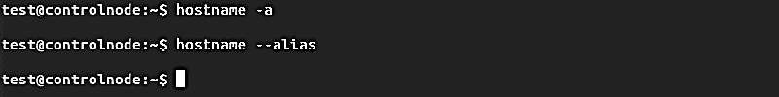

**Command: - $ sudo hostname -F [file path]**

to search a specific file (such as hostname or hosts) and change your computer’s hostname to match the content of the file.

Example:-



**Command: - $ hostname -b**

This makes your computer use the default hostname (**localhost**) until you set a different one

Example: -



**Que 26 Write the linux command to get information about the operating** **System.**answer: - The command ‘uname ‘ displays the information about the system.

**Syntax: $uname [OPTION]**

Example:-

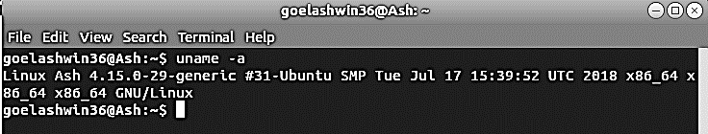

Options for uname command: -

**Command: - $uname -a**

It prints all the system information in the following order: Kernel name, network node hostname, kernel release date, kernel version, machine hardware name, hardware platform, operating system

Example:-



**Command: - $uname -s**

It prints the kernel name.

Example:-

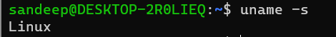

**Command:- $uname -n**

 It prints the hostname of the network node(current computer).

Example:-

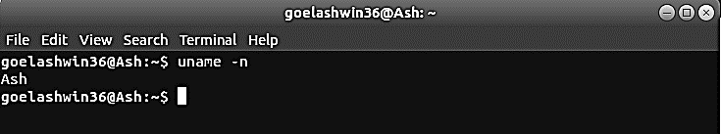

**Command:- $uname -r**

It prints the kernel release date.

Example:-

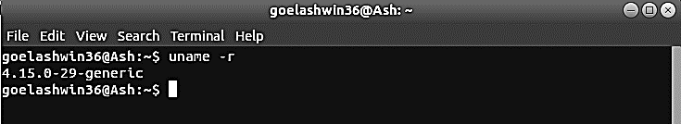

**Que 27 Write the linux command to display unique contents of a file.**answer: - The **uniq** command in Linux is a command-line utility that reports or filters out the repeated lines in a file.

**Syntax: - $uniq [OPTION] [INPUT[OUTPUT]]**

Example:-

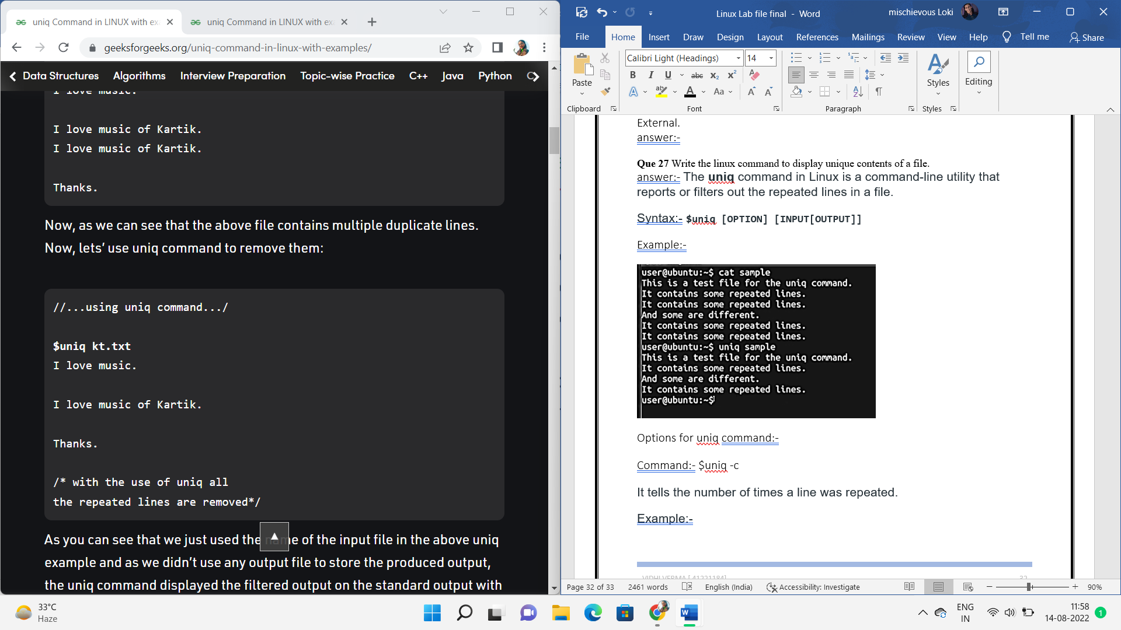

Options for uniq command: -

**Command: - $uniq -c**

It tells the number of times a line was repeated.

Example:-

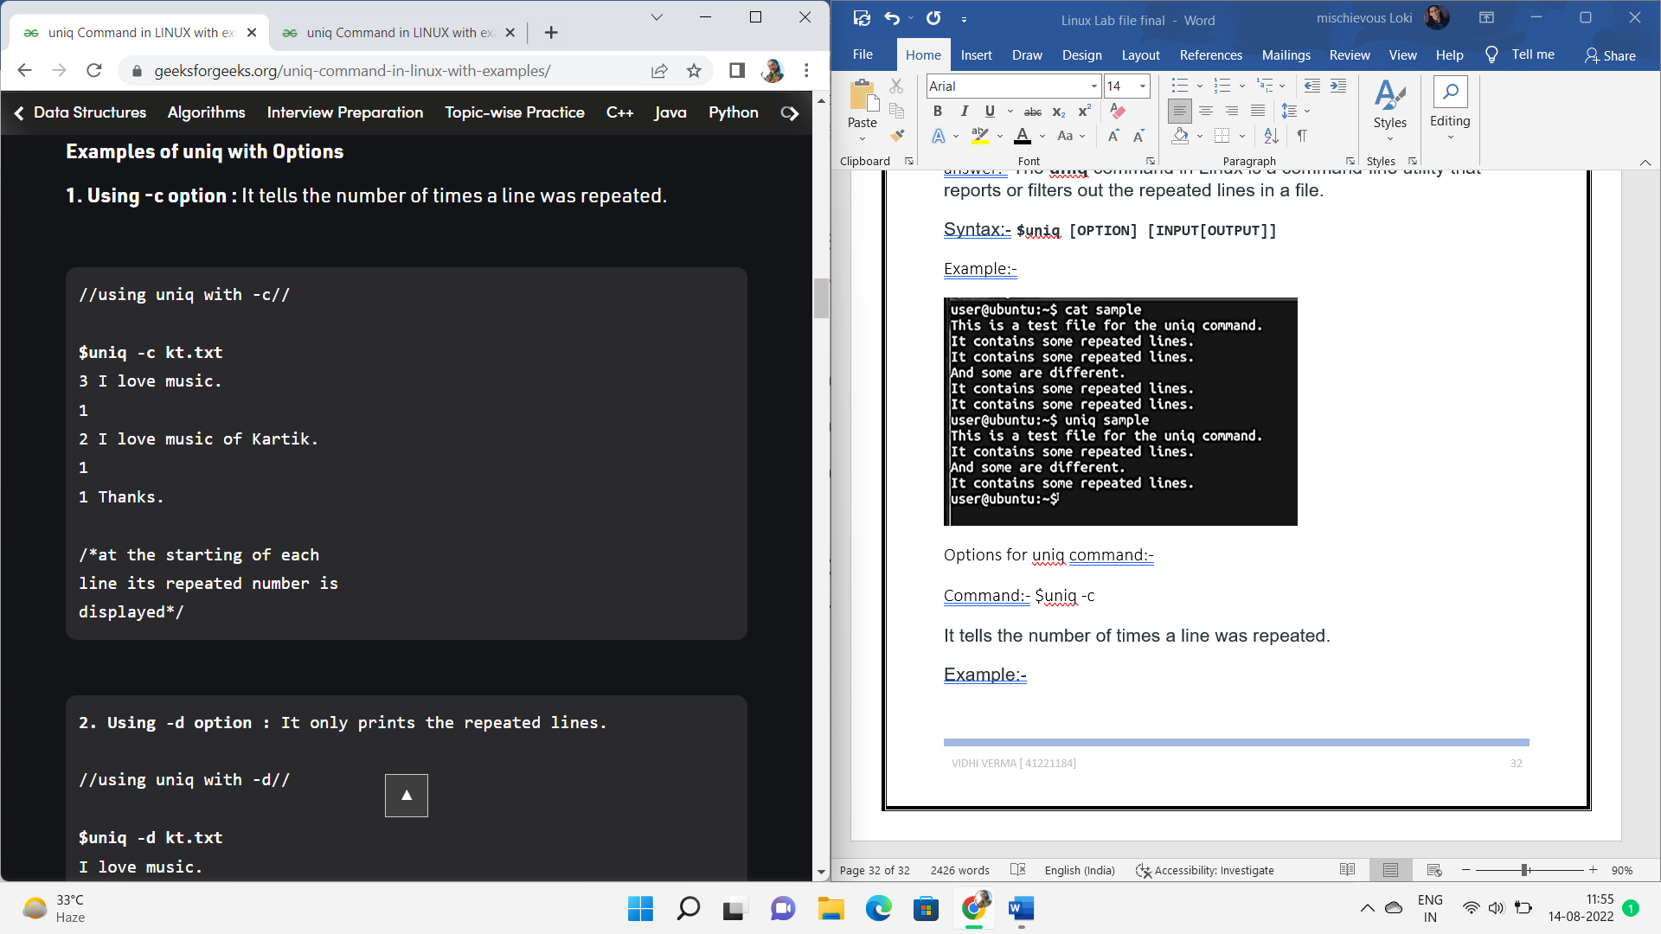

**Command:- $uniq -d**

It only prints the repeated lines.

Example:-

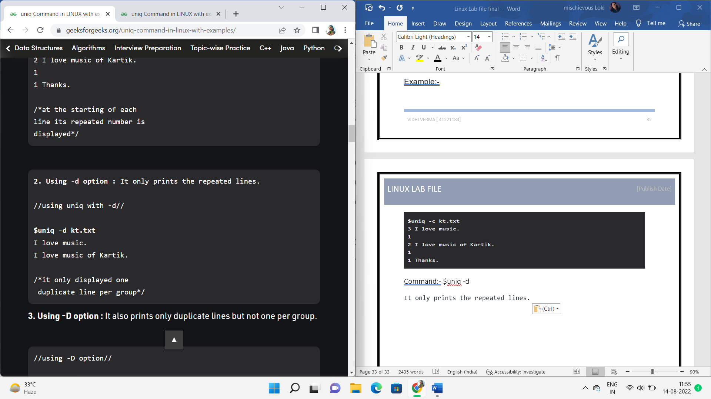

**Command: - $uniq -D**

 It also prints only duplicate lines but not one per group.

Example:-

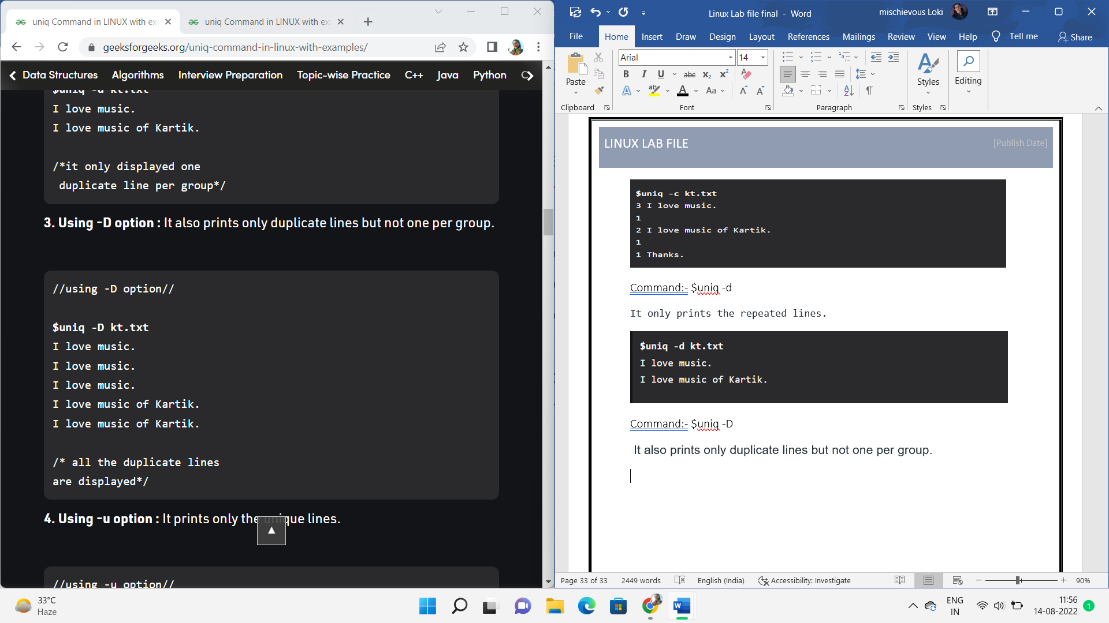

**Command: - $uniq -u**

It prints only the unique lines.

Example:-

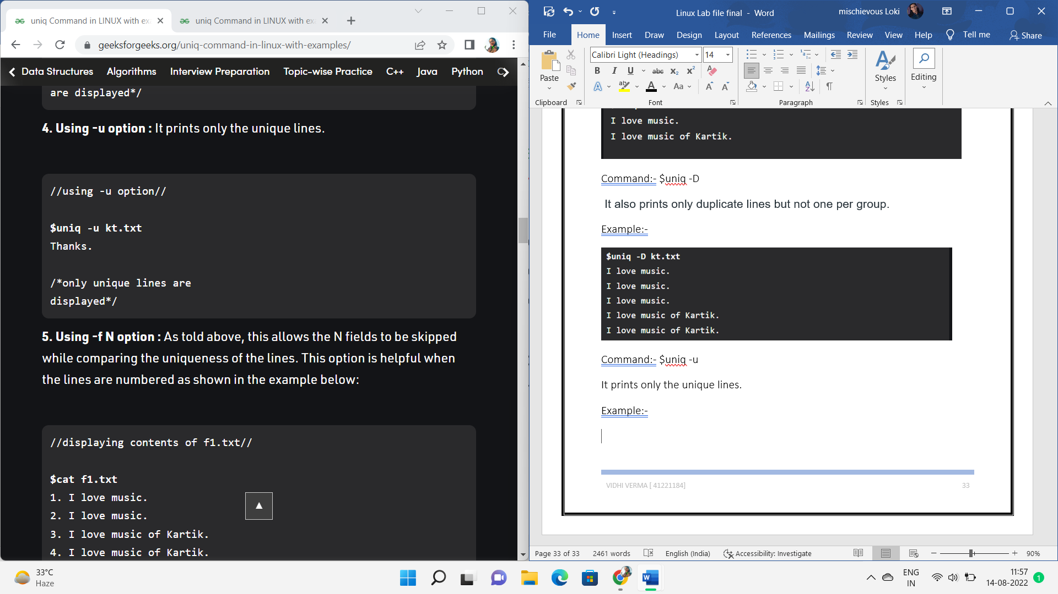

**Que 28 Write the linux command to view first 5 lines of a file.**answer:- head command is used to read selected number of lines from a file.

**Syntax: - $head [-number of lines] [file name]**

Example:-

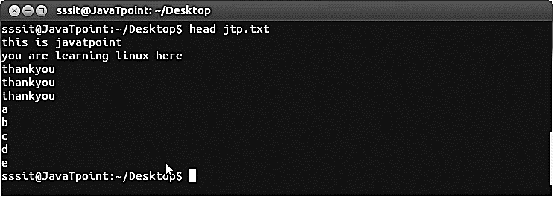

**Que 29 Write the linux command to view last 20 lines of a file.**answer:- to view last lines of a file we use tail command.

**Syntax: - $tail [- number of lines] [file name]**

Example: -

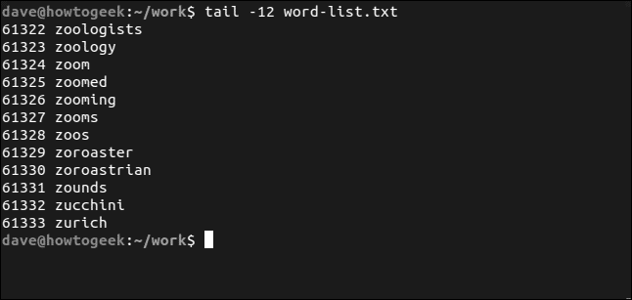

**Que 30 Write the linux command to extract specific column and field from a file.**answer: - to print a specific column of a file we use awk command.

**Syntax: - $awk ‘{action}’ [file name]**

Example:-

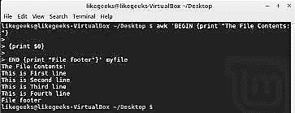

Options in awk command.

**Command: - $awk -F**Used to specify a file separator. The default separator is a blank space.

Example:-

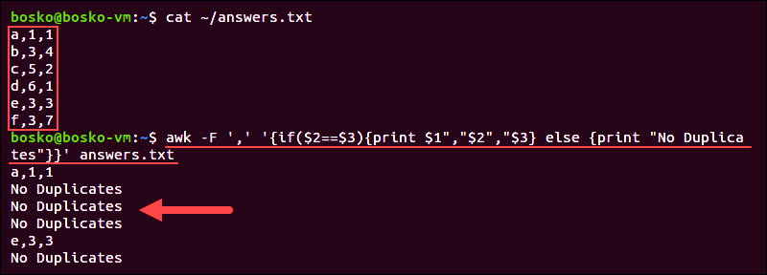

**Command: - $awk -FS**

Contains the character used to divide fields on the input line.

Example:-

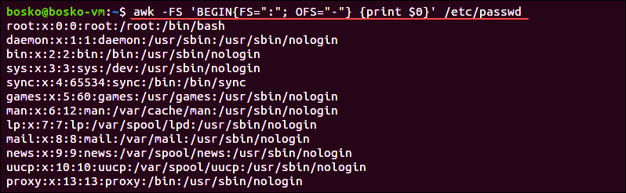

**Que 31 Write the linux command to merge two files vertically.**answer:- To merge files line by line, you can use the paste command. By default, the corresponding lines of each file are separated with tabs. This command is the horizontal equivalent to the cat command, which prints the content of the two files vertically.

**Syntax: - $paste [file1] [file2]**

Example:-



Options in paste command: -

**Command: - $paste -d [file1] [file2]**

To separate file data with /.

Example:-

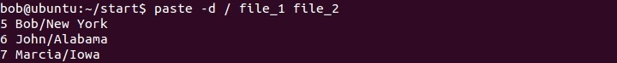

Command: - **$paste -s [file1] [file2]**

output can be presented in a horizontal fashion using the -s option

example:-



**Que 32 Write the linux command to sort a file.**answer: - SORT command in Linux is used to arrange the record in a specific order according to the option used.

Syntax: **-$ sort (option) [file name]**

Example: -

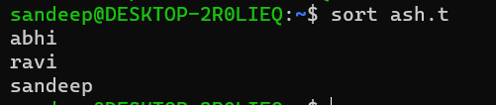

Options in sort command:-

Command**: - $sort -o :-**The output shows that the data is sorted and saved in another file.

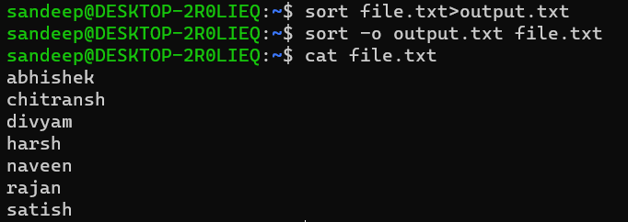

Command:- **$sort -r**:- to organize output in reverse order.

Example:-

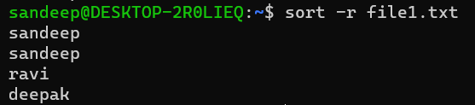

Command:- **$sort -c**

display the line number of the first word where unsortedness is present in the file and also the word.

Example:-



Command: - **$sort -u**

repeated items are removed from the output and that the data is also sorted.

Example: -

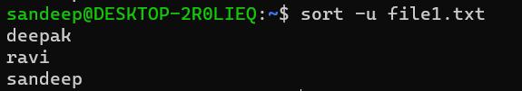

Que 33 **Write the linux command to find any character and replace it with some other character**.

Answer:- The tr command is a Linux command-line utility that translates or deletes characters from standard input (stdin) and writes the result to standard output (stdout). Use tr to perform different text transformations, including case conversion, squeezing or deleting characters, and basic text replacement

Syntax:- tr [options] SET1 [SET2]

Example:-



Options in tr command:-

Command:- $tr -s

To avoid multiple tabs and whitespaces in the output.

Example:-



Command:- $tr -d

Remove specific characters using the -d option.

Example:-



Command:- $tr -cd

Use the -c option to complement the characters in SET1. In the following example, we remove all characters except digits

Example:-



Command:- tr -t

to truncate SET1 to the length of SET2 and replaces only the first two characters.

Example:-



**Que 34 Write the linux command to change the permission of an existing file in relative manner**answer:- Linux chmod command is used to change the access permissions of files and directories. It stands for **change mode**.

Syntax:- chmod <options> <permissions> <file name>

Example:-

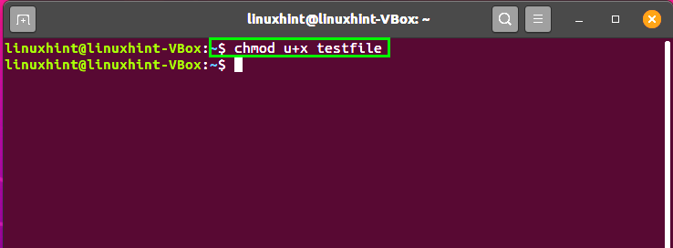

**Que 35 Write the linux command to change the permission of an existing file in** **absolute manner**answer:- Linux chmod command is used to change the access permissions of files and directories. It stands for **change mode**.

Syntax:- chmod <options> <permissions> <file name>

Example:-

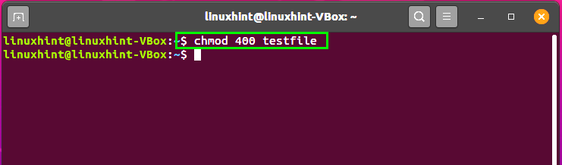

**Que 36 Write the linux command to create a hard link of a file**

Answer:- To create a hard links in Linux, we will use **ln utility.**

**Syntax:- $ln [option] [file name]**

**Example:-**

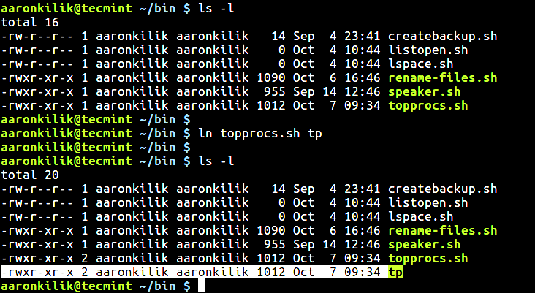

**Que 37 Write the linux command to create a soft link of a file as well as** directory  
answer:- To create a symbolic links in Linux, we will use same **ln utility** with -s switch.

Syntax:- **$ln -s [option] [file name]**

**Example:-**

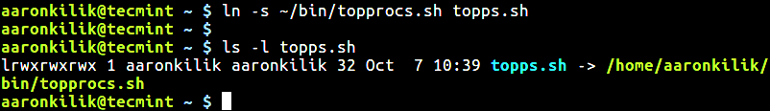

For directory.

Syntax:- **$ln -s [option] [directory name]**

**Example:-**



**Que 38 Write the linux command to search for specific pattern in a file.**

Answer:- grep command searches the given file for lines containing a match to the given strings or words.

Syntax:-$ grep 'word' filename

Example:-

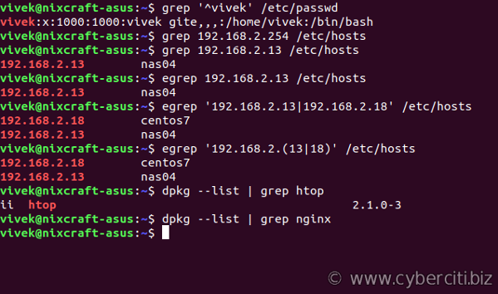

Options in grep command:-

Command:- $grep -i

Use the **-i** or **--ignore-case** option for turning off case sensitivity.

Example:-

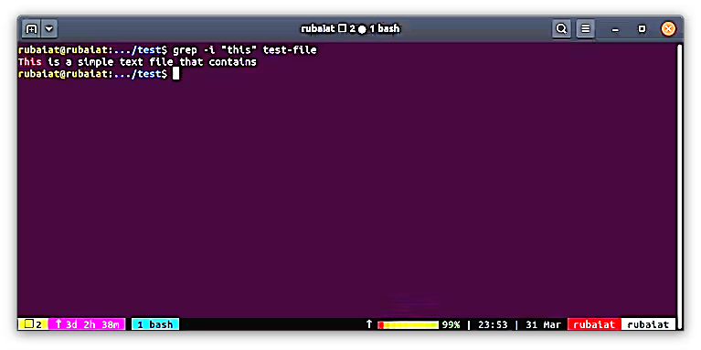

Command:- $grep -c

Displays total number of matches to the pattern.

Example:-

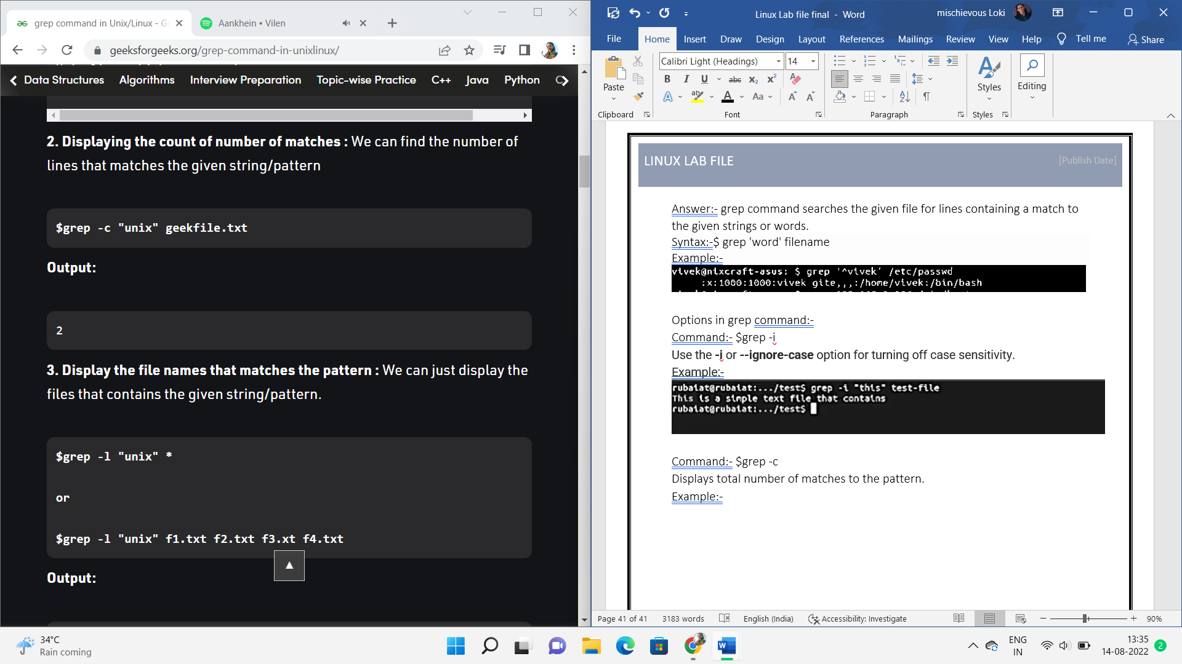

Command:- $grep -o

Display entire line matching the string.

Example:-

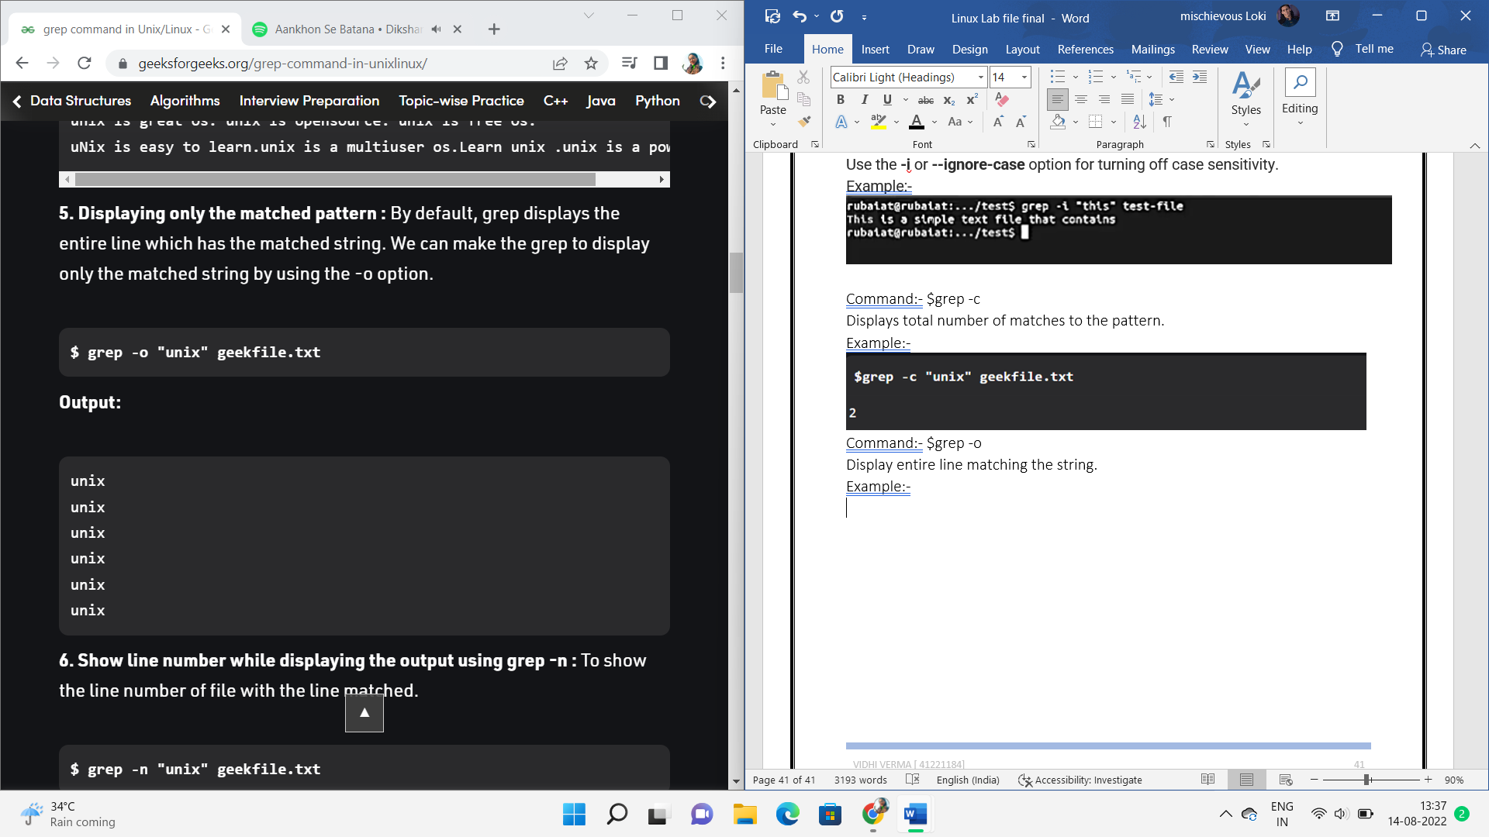

**Que 39 Write the linux command to print the result of a specific pattern.**

Answer:- grep command is used to print the result of a specific pattern in a file.

Command:- $grep -c

Displays total number of matches to the pattern.

Example:-



Command:- $grep -o

Display entire line matching the string.

Example:-



**Que 40 Write the linux command to replace any character/string with specified character/string using sed Command.**

Answer:- sed is a stream editor: it [filters](https://www.computerhope.com/jargon/f/filter.htm) and transforms [text](https://www.computerhope.com/jargon/t/text.htm).

## Syntax:- Sed [option] [script] [file]

Example:-

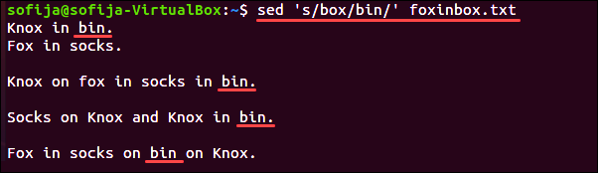

Options in sed command:-

Command:- $sed -n

The -n option disables automatic printing, while the substitute command p instructs sed to print lines where substitution occurs.

Example:-

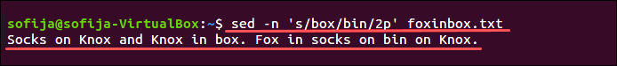

**Que 41 Write the linux command to show the use of awk Command**answer:- to print a specific column of a file we use awk command.

Syntax:- $awk ‘{ action}’ [file name]

Example:-



Options in awk command.

Command:- $awk -F  
Used to specify a file separator. The default separator is a blank space.

Example:-



Command:- $awk -FS

Contains the character used to divide fields on the input line.

Example:-



**Que 42 Write the linux command to list the processes for the current shell(ps).**answer:-  ps command provides information about the currently running processes, including their process identification numbers (PIDs). Both Linux and UNIX support the ps command to display information about all running process. The ps command gives a snapshot of the current processes.

Syntax:- $ps [option]

Example:-

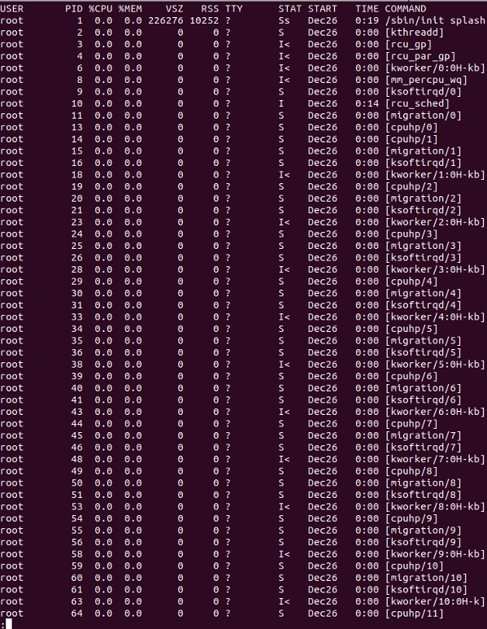

Options in ps command:-

Command:- $ps -a

View processes not associated with a terminal.

Example:-

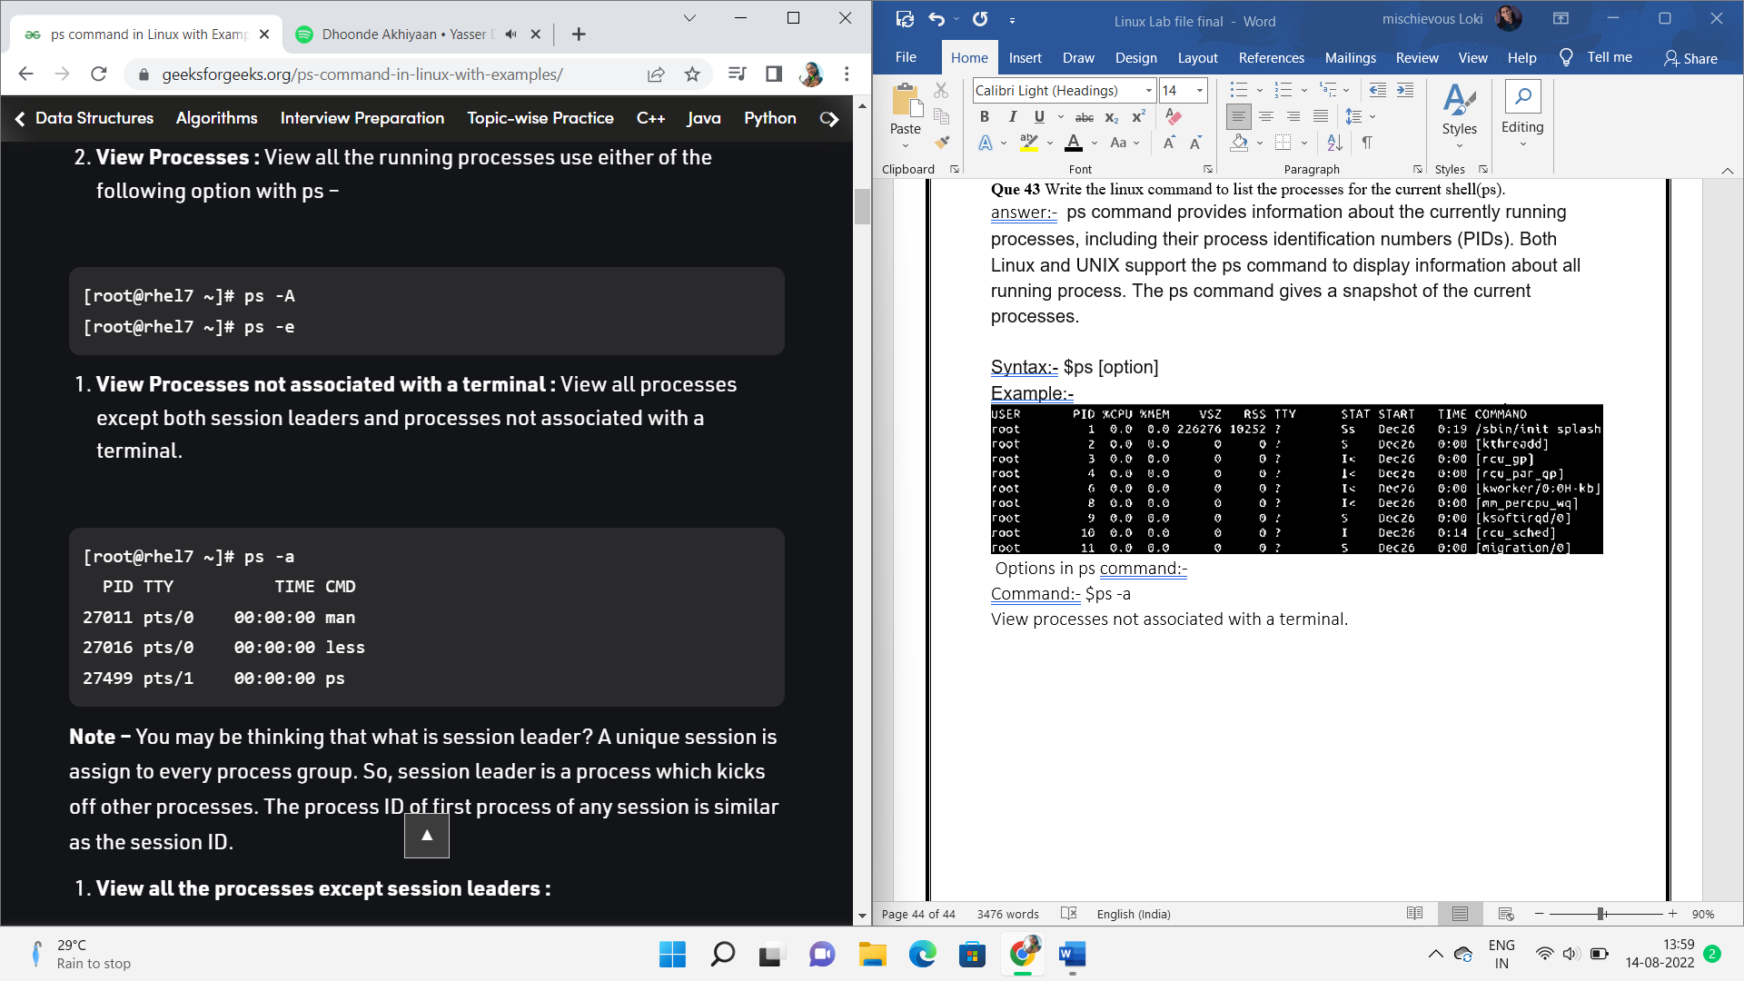

Command:- $ps -c

Select the process by the command name.

Example:-

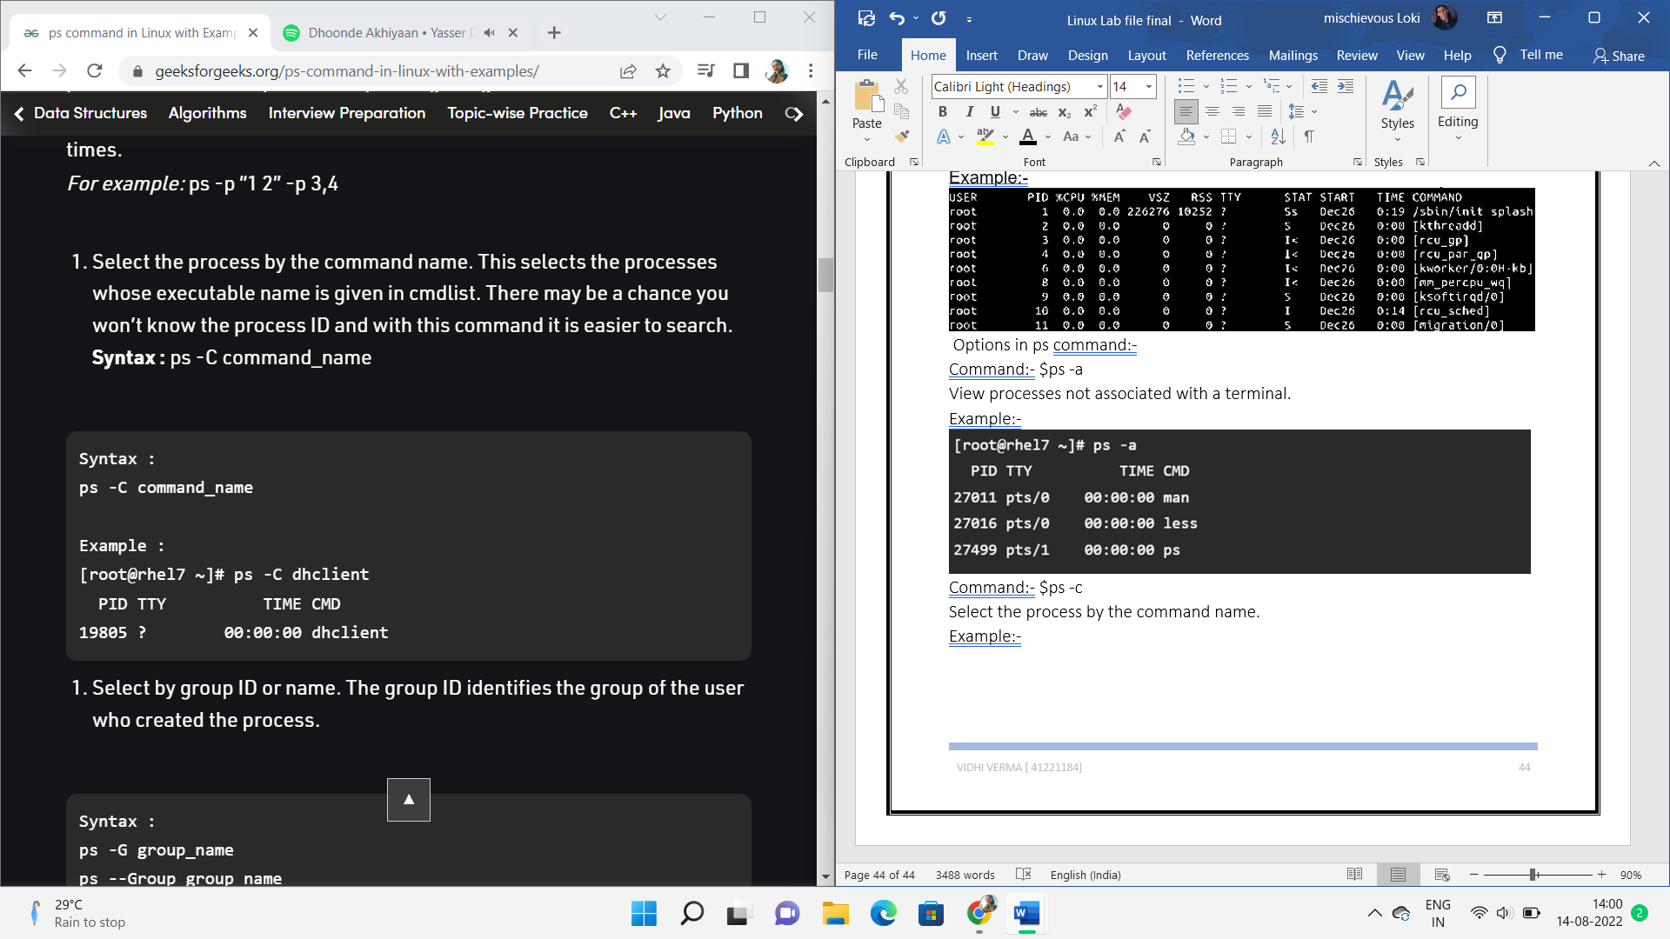

Command:- $ps -g

View by group id.

Example:-

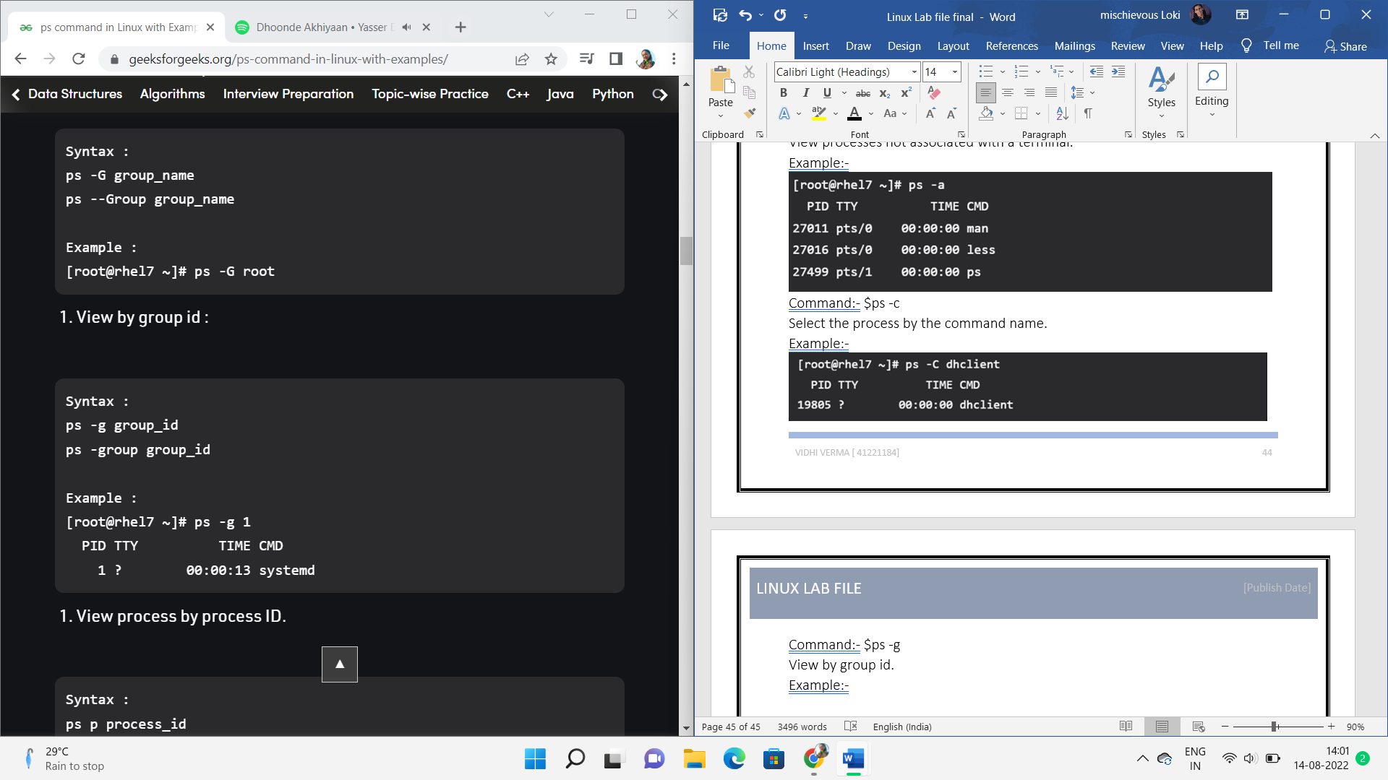

Command:- $ps -p

View by process id.

Example:-

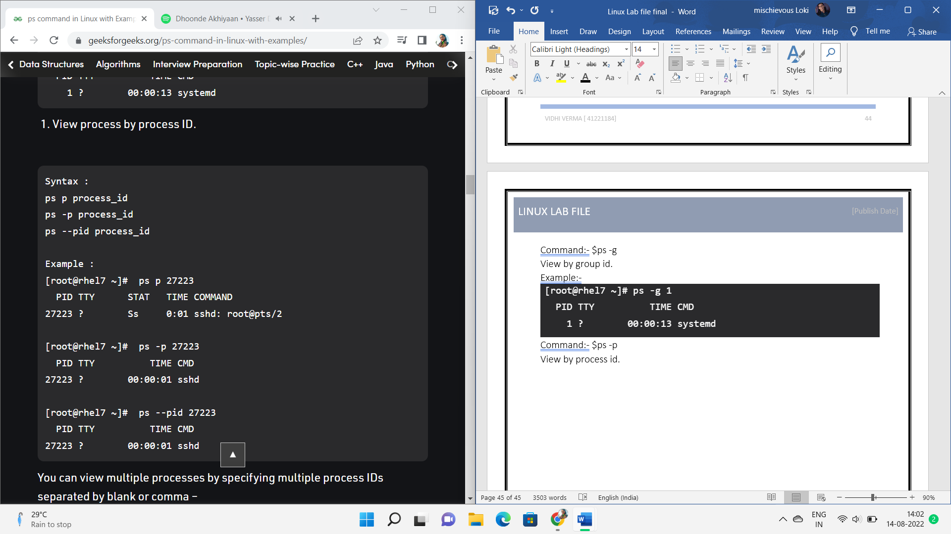

**Que 43 Write the linux command to display detailed information about** processes.  
answer:- ps command provides information about the currently running processes, including their process identification numbers (PIDs). Both Linux and UNIX support the ps command to display information about all running process. The ps command gives a snapshot of the current processes.

Syntax:- $ps [option]

Example:-



Options in ps command:-

Command:- $ps -a

View processes not associated with a terminal.

Example:-



Command:- $ps -c

Select the process by the command name.

Example:-



Command:- $ps -g

View by group id.

Example:-



Command:- $ps -p

View by process id.

Example:-



**Que 44 Write the linux command to stop any currently running process**answer:- to stop a current running process we can use the kill command. The kill command will kill a single process at a time with the given process ID. It will send a **SIGTERM** signal indicating to a process to stop. It waits for the program to run its shutdown routine.

Syntax:- kill <processID>

To diplay all the available signals you can use kill -l command

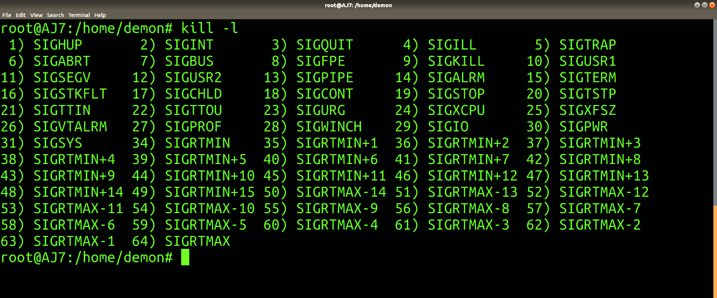

To kill a particular process:-

Syntax:- $kill [pid]

Example:-

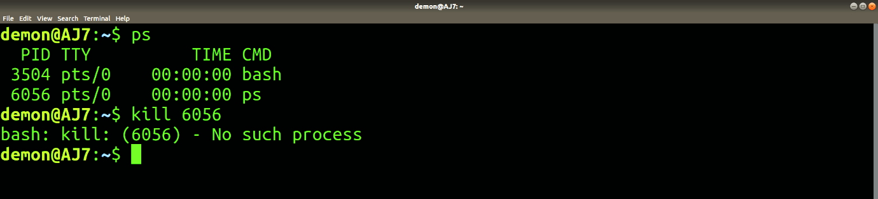

**Que 45 Write the linux command to Kill a process**answer:- The kill command will kill a single process at a time with the given process ID. It will send a **SIGTERM** signal indicating to a process to stop. It waits for the program to run its shutdown routine.

Syntax:- kill <processID>

To diplay all the available signals you can use kill -l command

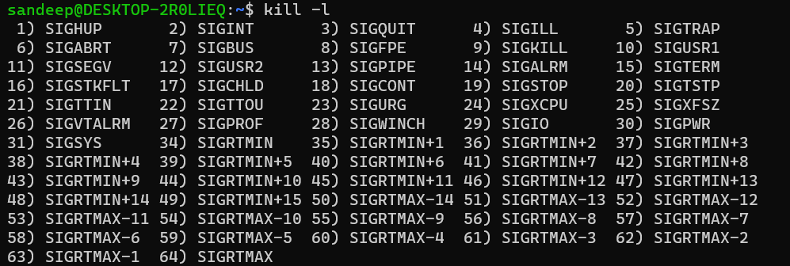

To kill a particular process:-

Syntax:- $kill [pid]

Example:-



**Que 46 Write the linux command to create a tar file.**

Answer:- syntax :- **tar [OPERATION_AND_OPTIONS] [ARCHIVE_NAME] [FILE_NAME(s)]**

**Copy**

* OPERATION - Only one operation argument is allowed and required. The most frequently used operations are:
  + --create (-c) - Create a new tar archive.
  + **--extract (-x)** - Extract the entire archive or one or more files from an archive.
  + **--list (-t)** - Display a list of the files included in the archive
* options - The most frequently used operations are:
  + **--verbose (-v)** - Show the files being processed by the tar command.
  + **--file=archive=name (-f archive-name)** - Specifies the archive file name.
* **ARCHIVE_NAME** - The name of the archive.
* **FILE_NAME(s)** - A space-separated list of filenames to be extracted from the archive. If not provided, the entire archive is extracted.

**Example** :-

**Que 47 Write the linux command to create a Zip file and Unzip it.**

Answer: - To zip a single file named**file.txt;**to a zip file named **test.zip**, the command would be:

Syntax: - $ zip test.zip file.txt

Example: -



 zip multiple files with the zip command. Let’s create some files named **file1**.**txt**, **file2**.**txt**, **file3**.**txt**, and **file4**.**txt**

**syntax: - $ zip files.zip file1.txt file2.txt file3.txt file4.txt**

example: -

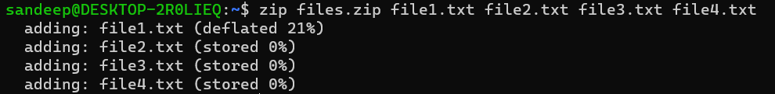

to zip all the files ending with .txt extension in a zip file, named files1.zip,

syntax: - $ zip testfile.zip *.txt

example: -

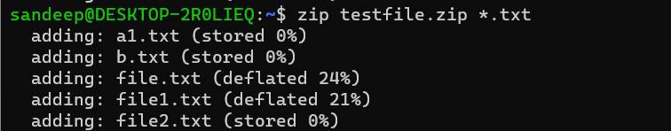

## **Unzip Command in Linux: -**With the unzip command, you can easily extract content from a zip file. To unzip a file, use the following syntax:

**Syntax:- $ unzip options zip file**

Example:-   
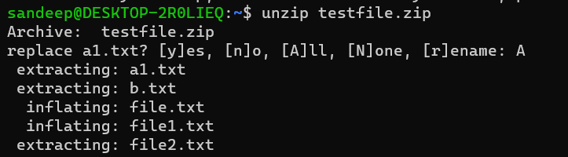

**Que 48 Write a shell script to find the largest of two numbers**answer:-

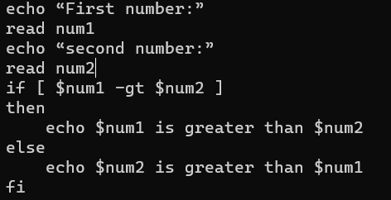

Output:-

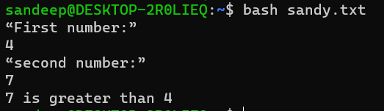

**Que 49 Write a shell script to check whether a number is even or odd**

Answer:-

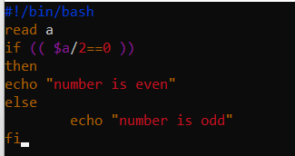

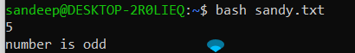Output:-

**Que 50 Write a shell script to find largest of three given number.**answer:-

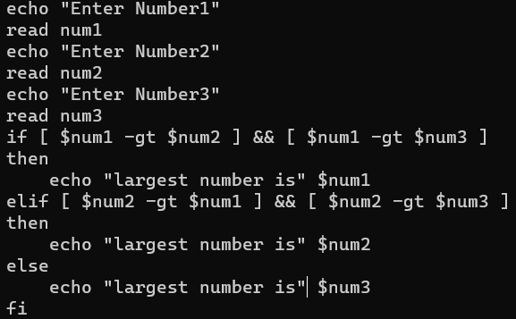

Output:-

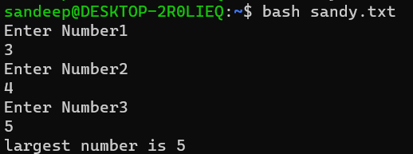

**Que 51 Write a shell script to greet the user according to the week of the day.**answer:-

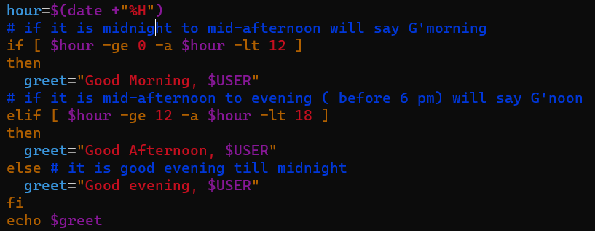

**Output:-**

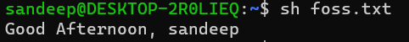

**Que 52 Write a shell script to display the number of vowels and consonants in a string**answer:-

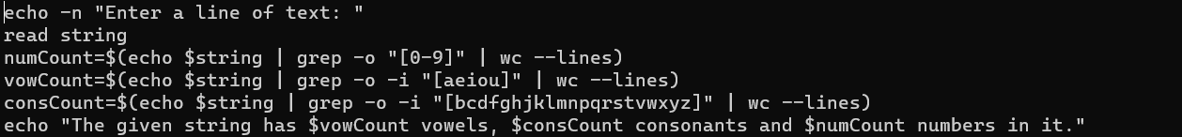

Output:-



Que 53 Write a shell script to perform arithmetic operation using case---esac.  
answer:-

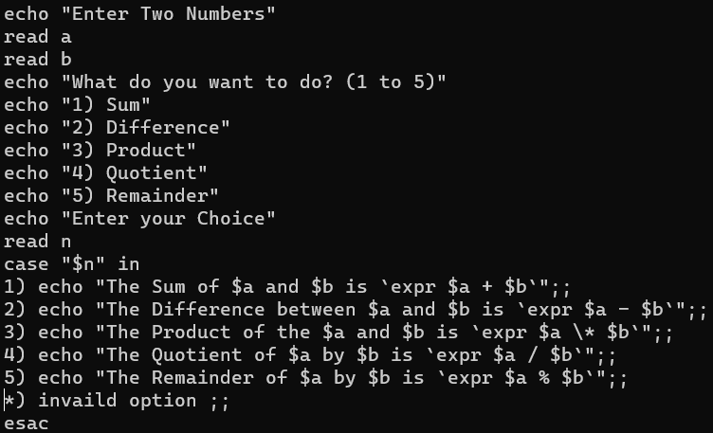output:-

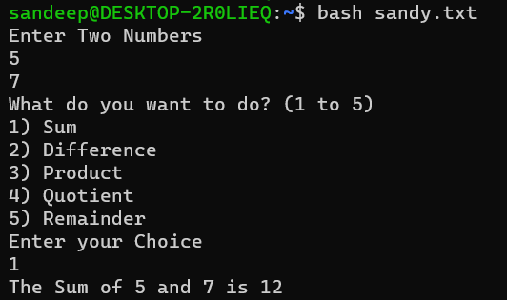

Que 54 Write a shell script to count words, lines and characters in a file  
answer:-

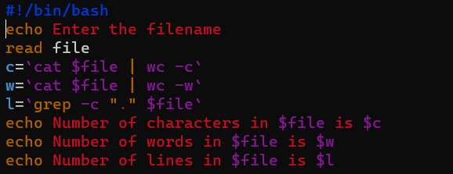

output:-

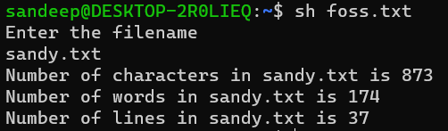

Que 55 **Write a shell script to check whether the year entered is leap or not**.  
answer:-

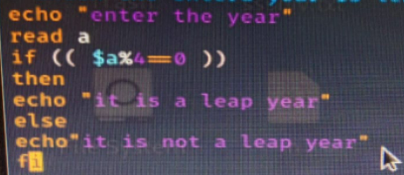

output:-

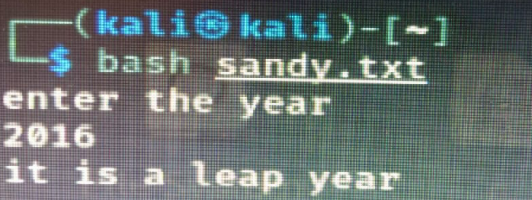

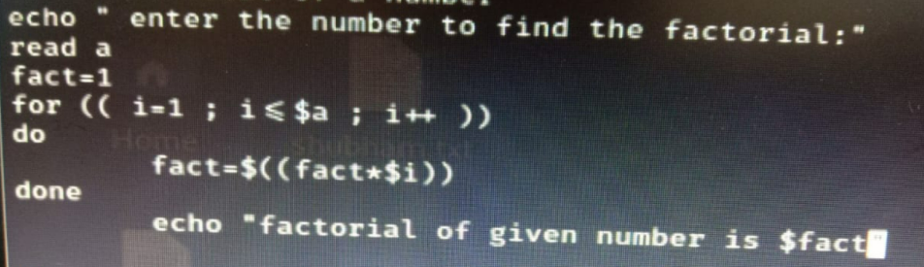Que 56 **Write a shell script to find factorial of a number.**answer:-

Output:-

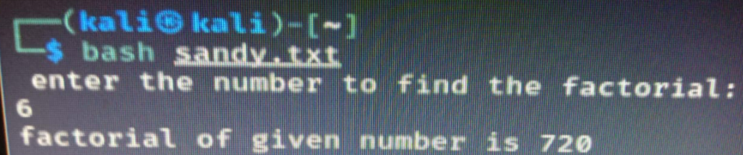

Que 57 **Write a shell script to generate a multiplication table**  
answer:-

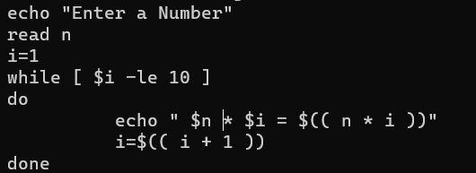

Output:-

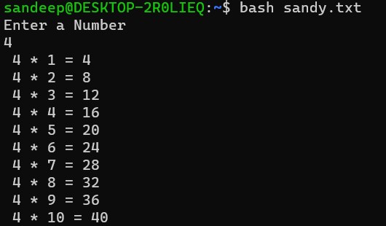

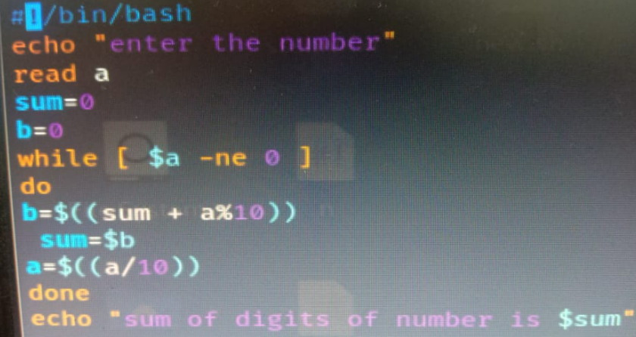Que 58 **Write a shell script to add the digits of a number**  
answer:-

output:-

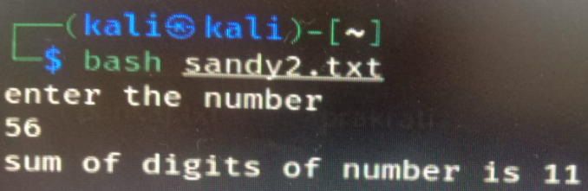

**Que 59** **Write a shell script to reverse a string.**

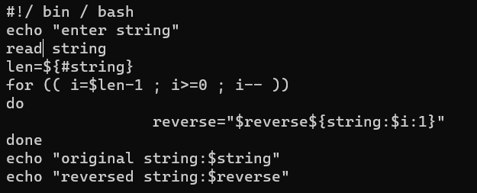

output:-

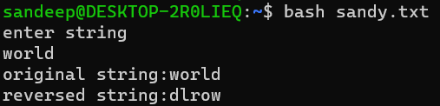

Que 60 **Write a shell script to check whether a number entered is prime or not**.

Answer:-

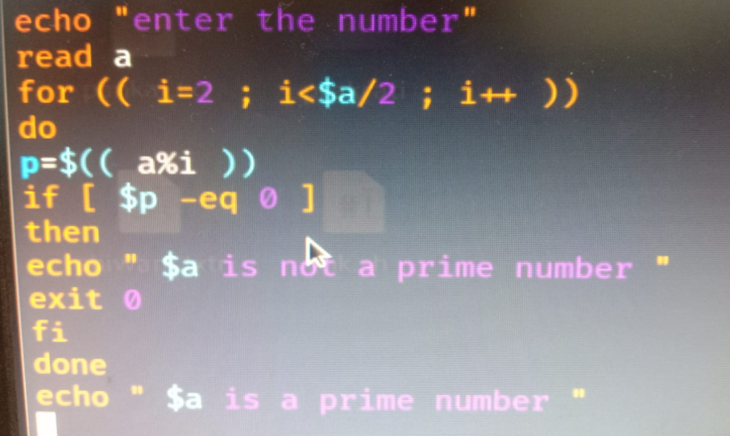

Output:-

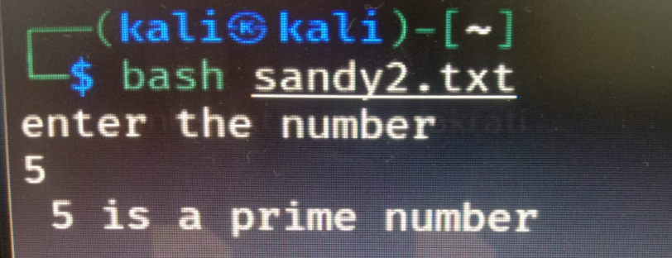

Que 61 **Write a shell script to generate Fibonacci Series**.  
answer:-

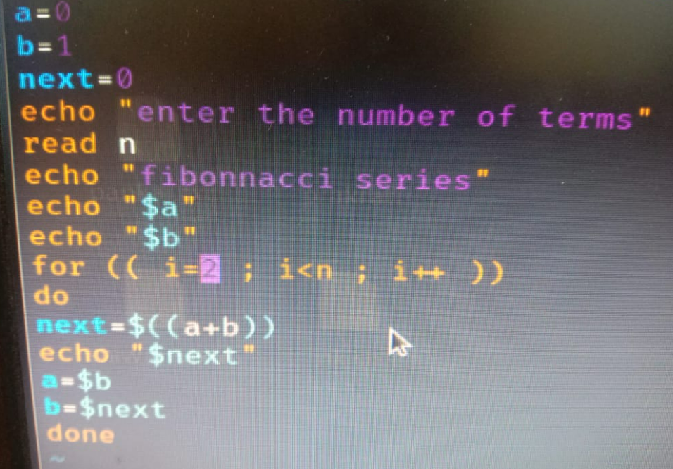

Output:-

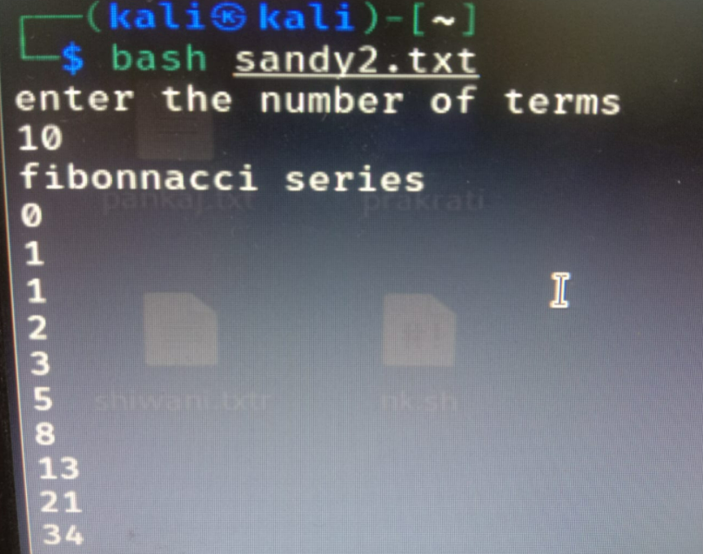

Que 62 **Write a shell script to check whether a given number is a palindrome**

Answer:-

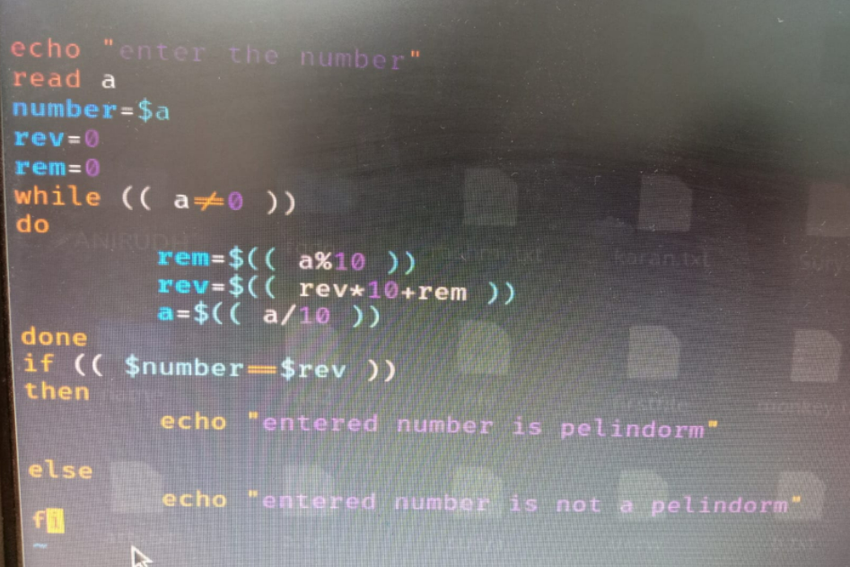

Output:-

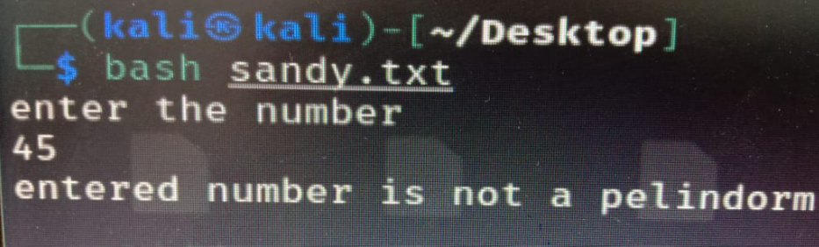

Que 63 **Write the linux command to display a list of CPU-intensive tasks on the system.**

### Answer:- top Command is used to View Linux CPU Load.

### Syntax:- $ top

### Example:-

### 

Que 64 **Write the linux command to displays the processes on the system in the form of a tree**  
Answer:- pstree command is used to display processes in the form of tree.

Syntax:- **$pstree**

Example:-

